# Descriptive Statistics – New religious Sermon Dataset

The descriptive statistics below include the two following variables:

* **Absolute coverage**: The raw number of sermons coming from a certain feature
* **Relative Coverage:** Represents the percentage of observations in each category relative to the total number of observations across all categories.
* **Relative Coverage adjusted**: The Adjusted Relative coverage is the proportion of observations in a category, adjusted by that category’s population share. For example, relative coverage for each U.S. state is calculated by dividing the state’s Relative coverage by its proportion of the total U.S. population.

Note: Both the relative coverages are expressed as percentages.

Table of Contents

Descriptive Statistics – New religious Sermon Dataset 1

1 Coverage Variables 3

1.1 Coverage by Year 3

1.2 Coverage by State 4

1.3 Coverage by Denomination of Sermon 5

1.4 Coverage by Religious Family 6

2 Tabulation of Variables 10

2.1 Tabulation of star rating: 10

2.2 Tabulation of Binned Views: 10

2.3 Tabulation of Binned Sermons Contributed: 10

3 Exhibits: 11

3.1 State: Relative Coverage 11

3.2 State: Adjusted Relative Coverage 11

3.3 Election-Related Words 12

3.4 Presidential Election Candidates’ Mentions 17

3.5 RDD-Style Graphs: Sermon Count and View Count 21

4 Pastor-Level Controls 24

4.1 Married0 24

4.2 Children0: 25

4.3 Edu theology0: 32

4.4 Edu theological0: 34

4.5 Edu0: 35

4.6 Denom_index: 37

4.7 Family_index: 38

4.8 Exp bin: 38

## Coverage Variables

### Coverage by Year

|  |  |  |
| --- | --- | --- |
| **Year** | **Absolute Coverage** | **Relative Coverage** |
| 2000 | 2470 | 1.488 |
| 2001 | 6776 | 4.104 |
| 2002 | 8295 | 5.133 |
| 2003 | 8084 | 4.953 |
| 2004 | 7413 | 4.514 |
| 2005 | 8207 | 5.001 |
| 2006 | 9043 | 5.572 |
| **2007** | **11006** | 6.698 |
| 2008 | 9708 | 5.934 |
| 2009 | 8392 | 5.117 |
| 2010 | 6682 | 4.085 |
| 2011 | 7100 | 4.333 |
| 2012 | 6381 | 3.879 |
| 2013 | 6046 | 3.698 |
| 2014 | 6312 | 3.821 |
| 2015 | 5447 | 3.293 |
| 2016 | 4945 | 2.988 |
| 2017 | 4245 | 2.582 |
| 2018 | 5252 | 3.176 |
| 2019 | 4942 | 2.987 |
| 2020 | 4868 | 2.975 |
| 2021 | 5574 | 3.383 |
| 2022 | 8417 | 5.091 |
| 2023 | 5331 | 3.234 |
| 2024 | 3197 | 1.954 |

The highest absolute (and relative) coverage of sermons is from the year 2007, while the lowest percentage of sermons is from the year 2000.

### Coverage by State

|  |  |  |  |
| --- | --- | --- | --- |
| **State** | **Absolute Coverage** | **Relative Coverage** | **Adjusted Relative Coverage (Relative coverage / Percent population in state)** |
| Alabama | 5275 | 3.214 | 2.034 |
| Alaska | 629 | 0.383 | 1.72 |
| Arizona | 4025 | 2.452 | 1.345 |
| Arkansas | 3272 | 1.994 | 2.099 |
| California | 6073 | 3.7 | 0.307 |
| Colorado | 2111 | 1.286 | 0.842 |
| Connecticut | 317 | 0.193 | 0.16 |
| Delaware | 189 | 0.115 | 0.414 |
| Florida | 10161 | 6.191 | 1.09 |
| Georgia | 6904 | 4.205 | 1.446 |
| Hawaii | 164 | 0.1 | 0.232 |
| Idaho | 412 | 0.251 | 0.546 |
| Illinois | 6745 | 4.109 | 0.931 |
| Indiana | 7589 | 4.624 | 2.14 |
| Iowa | 1759 | 1.072 | 1.031 |
| Kansas | 3751 | 2.285 | 2.392 |
| Kentucky | 5144 | 3.134 | 2.182 |
| Louisiana | 4736 | 2.885 | 1.817 |
| Maine | 325 | 0.198 | 0.437 |
| Maryland | 2862 | 1.744 | 0.926 |
| Massachusetts | 1272 | 0.775 | 0.344 |
| Michigan | 4653 | 2.835 | 0.803 |
| Minnesota | 926 | 0.564 | 0.323 |
| Mississippi | 2726 | 1.661 | 1.643 |
| Missouri | 3749 | 2.284 | 1.149 |
| Montana | 49 | 0.03 | 0.093 |
| Nebraska | 211 | 0.129 | 0.211 |
| Nevada | 1109 | 0.676 | 0.952 |
| New Hampshire | 97 | 0.059 | 0.135 |
| New Jersey | 1133 | 0.688 | 0.23 |
| New Mexico | 2471 | 1.505 | 2.329 |
| New York | 3471 | 2.114 | 0.314 |
| North Carolina | 4631 | 2.821 | 0.986 |
| North Dakota | 206 | 0.126 | 0.55 |
| Ohio | 7352 | 4.477 | 1.11 |
| **Oklahoma** | 6205 | 3.78 | 3.083 |
| Oregon | 1691 | 1.03 | 0.847 |
| Pennsylvania | 5488 | 3.344 | 0.766 |
| Rhode Island | 34 | 0.021 | 0.056 |
| South Carolina | 7306 | 4.451 | 3.122 |
| South Dakota | 745 | 0.453 | 1.69 |
| Tennessee | 7936 | 4.835 | 2.392 |
| **Texas** | 14746 | 8.984 | 1.213 |
| Utah | 95 | 0.058 | 0.073 |
| Vermont | 39 | 0.024 | 0.11 |
| Virginia | 4670 | 2.845 | 1.131 |
| Washington | 2888 | 1.758 | 0.84 |
| West Virginia | 3093 | 1.884 | 2.933 |
| Wisconsin | 2215 | 1.35 | 0.708 |
| Wyoming | 483 | 0.294 | 1.677 |

The highest absolute (and relative) coverage of sermons is in the state of Texas, and the lowest absolute coverage of sermons is in Vermont and Rhode Island.

By using US state census data from 2000, the highest adjusted relative coverage of sermons is found to be in Oklahoma, while the lowest adjusted relative coverage is in Rhode Island.

### Coverage by Denomination of Sermon

|  |  |  |  |
| --- | --- | --- | --- |
| **Index** | **Denomination** | **Absolute Coverage** | **Relative Coverage** |
| 1 | *Other | 3262 | 1.991 |
| 2 | Adventist | 182 | 0.155 |
| 3 | Anglican | 486 | 0.296 |
| 4 | Apostolic | 646 | 0.445 |
| 5 | Assembly Of God | 6911 | 4.395 |
| **6** | **Baptist** | **54723** | **33.607** |
| 7 | Bible Church | 803 | 0.49 |
| 8 | Brethren | 456 | 0.278 |
| 9 | Calvary Chapel | 1974 | 1.205 |
| 10 | Catholic | 1867 | 1.186 |
| 11 | Charismatic | 1423 | 0.886 |
| 12 | Christian Church | 2063 | 1.262 |
| 13 | Christian Missionary Alliance | 1280 | 0.78 |
| 14 | Christian/Church Of Christ | 17288 | 10.562 |
| 15 | Church Of God | 4509 | 2.765 |
| 16 | Congregational | 831 | 0.506 |
| 17 | Disciples Of Christ | 88 | 0.054 |
| 18 | Episcopal | 207 | 0.126 |
| 19 | Episcopal/Anglican | 230 | 0.14 |
| 20 | Evangelical Free | 1296 | 0.796 |
| 21 | Evangelical/Non-Denominational | 18825 | 11.587 |
| 22 | Foursquare | 981 | 0.6 |
| 23 | Free Methodist | 845 | 0.515 |
| 24 | Friends | 285 | 0.174 |
| 25 | Grace Brethren | 15 | 0.009 |
| 26 | Holiness | 1547 | 0.957 |
| 27 | Independent Bible | 6927 | 4.226 |
| 28 | Lutheran | 5436 | 3.341 |
| 29 | Mennonite | 243 | 0.148 |
| 30 | Methodist | 5437 | 3.319 |
| 31 | Nazarene | 2896 | 1.764 |
| 32 | Orthodox | 577 | 0.352 |
| 33 | Pentecostal | 7789 | 5.024 |
| 34 | Presbyterian/Reformed | 5253 | 3.266 |
| 35 | Salvation Army | 741 | 0.507 |
| 36 | Seventh-Day Adventist | 222 | 0.178 |
| 37 | United Methodist | 3348 | 2.067 |
| 38 | Vineyard | 322 | 0.197 |
| 39 | Wesleyan | 1905 | 1.161 |

The highest absolute and relative coverage of sermons is in the Baptist denomination and the lowest absolute coverage is in the Disciples of Christ denomination.

### Coverage by Religious Family

To explore coverage using a broader grouping of religious denominations, a new variable for religious family was created. The table below shows how each denomination (as listed in the table under Section 1.3) is categorized into its corresponding religious family, based on the classification provided by [ARDA](https://www.thearda.com/us-religion/group-profiles/families).

Note: The denominations labelled 'Evangelical/Non-Denominational' and 'Independent Bible' were classified as 'Other groups' because the characteristics of the denominations did not fit into other families.

|  |  |
| --- | --- |
| **Denomination** | **Family (ARDA)** |
| *Other | Other Groups Family |
| Adventist | Adventist Family |
| Anglican | Anglican/Episcopal Family |
| Apostolic | Pentecostal Family |
| Assembly of God | Pentecostal Family |
| Baptist | Baptist Family |
| Bible Church | Pentecostal Family |
| Brethren | Friends/Brethren Family |
| Calvary Chapel | Pentecostal Family |
| Catholic | Catholic Liturgical Family |
| Charismatic | Pentecostal Family |
| Christian Church | Restorationists Family |
| Christian/Church of Christ | Restorationists Family |
| Christian Missionary Alliance | Holiness Family |
| Church of God | Pentecostal Family |
| Congregational | Congregationalists (United Church of Christ) Family |
| Disciples of Christ | Restorationists Family |
| Episcopal | Anglican/Episcopal Family |
| Episcopal/Anglican | Anglican/Episcopal Family |
| Evangelical Free | Methodist Family |
| Evangelical/Non-Denominational | Other Groups Family |
| Foursquare | Pentecostal Family |
| Free Methodist | Holiness Family |
| Friends | Friends/Brethren Family |
| Grace Brethren | Friends/Brethren Family |
| Holiness | Holiness Family |
| Independent Bible | Other Groups Family |
| Lutheran | Lutheran Family |
| Mennonite | Mennonite/Amish Family |
| Methodist | Methodist Family |
| Nazarene | Froehlich Churches Family |
| Orthodox | Eastern Liturgical (Orthodox) Family |
| Pentecostal | Pentecostal Family |
| Presbyterian/Reformed | Presbyterian/Reformed Family |
| Salvation Army | Holiness Family |
| Seventh-day Adventist | Adventist Family |
| United Methodist | Methodist Family |
| Vineyard | Pentecostal Family |
| Wesleyan | Holiness Family |

The absolute and relative coverages of the religious families can be found below. The Adjusted Relative coverage by family is calculated as the relative coverage divided by the number of adherents per religious family (according to the [ARDA](https://www.thearda.com/us-religion/group-profiles/families) 2020 data).

Adherents, according to the definition by the [USRC](https://www.usreligioncensus.org/), are defined as the most complete count of individuals affiliated with a congregation, including members, children of members, other attendees who are not members.

|  |  |  |  |  |
| --- | --- | --- | --- | --- |
| **Index** | **Family (ARDA)** | **Absolute Coverage** | **Relative Coverage** | **Adjusted** **Relative Coverage (Relative coverage / adherents per religious family)** |
| 1 | Adventist Family | 404 | 0.246 | 0.082 |
| 2 | Anglican/Episcopal Family | 923 | 0.562 | 0.519 |
| 3 | **Baptist Family** | **54724** | **33.341** | 2.017 |
| 4 | Catholic Liturgical Family | 1867 | 1.137 | 0.027 |
| 5 | Congregationalists (United Church of Christ) Family | 831 | 0.506 | 0.762 |
| 6 | Eastern Liturgical (Orthodox) Family | 577 | 0.352 | 0.439 |
| 7 | Friends/Brethren Family | 758 | 0.461 | 3.113 |
| 8 | **Froehlich Churches Family** | 2896 | 1.764 | **97.501** |
| 9 | Holiness Family | 6323 | 3.849 | 2.384 |
| 10 | Lutheran Family | 5436 | 3.312 | 0.86 |
| 11 | Mennonite/Amish Family | 243 | 0.148 | 0.358 |
| 12 | Methodist Family | 10082 | 6.142 | 0.908 |
| 13 | Other Groups Family | 29014 | 17.677 | 1.207 |
| 14 | Pentecostal Family | 25363 | 15.45 | 3.837 |
| 15 | Presbyterian/Reformed Family | 5253 | 3.2 | 1.899 |
| 16 | Restorationists Family | 19439 | 11.843 | 5.382 |

In terms of absolute coverage and the relative coverage, the highest representation of sermons is in the Baptist Family, while the lowest is in the Mennonite/Amish Family.

Regarding the adjusted relative coverage (based on the number of adherents per family), the Froehlich Churches Family has the highest representation, while the Catholic Liturgical Family has the lowest.

## Tabulation of Variables

### Tabulation of star rating:

|  |  |  |  |
| --- | --- | --- | --- |
| Stars | Freq. | Percent | Cum. |
| 0 | 3 | 0.00 | 0.00 |
| 1 | 705 | 0.43 | 0.43 |
| 2 | 2305 | 1.40 | 1.84 |
| 3 | 84860 | 51.70 | 53.54 |
| 4 | 61014 | 37.17 | 90.71 |
| 5 | 15246 | 9.29 | 100.00 |
| Total | 164133 | 100.00 |  |

### Tabulation of Binned Views:

|  |  |  |  |
| --- | --- | --- | --- |
|  | Freq. | Percent | Cum. |
| 0-25 | 149855 | 91.30 | 91.30 |
| 25-50 | 6229 | 3.80 | 95.10 |
| 50-100 | 1858 | 1.13 | 96.23 |
| 100-500 | 2216 | 1.35 | 97.58 |
| 500-1000 | 3975 | 2.42 | 100.00 |
| Total | 164133 | 100.00 |  |
|  | | | |

### Tabulation of Binned Sermons Contributed:

|  |  |  |  |
| --- | --- | --- | --- |
|  | Freq. | Percent | Cum. |
| 0-25 | 22800 | 13.89 | 13.89 |
| 25-50 | 14284 | 8.70 | 22.59 |
| 50-100 | 18712 | 11.40 | 33.99 |
| 100-500 | 62261 | 37.93 | 71.93 |
| 500-1514 | 46076 | 28.07 | 100.00 |
| Total | 164133 | 100.00 |  |
|  | | | |

## Exhibits:

### State: Relative Coverage

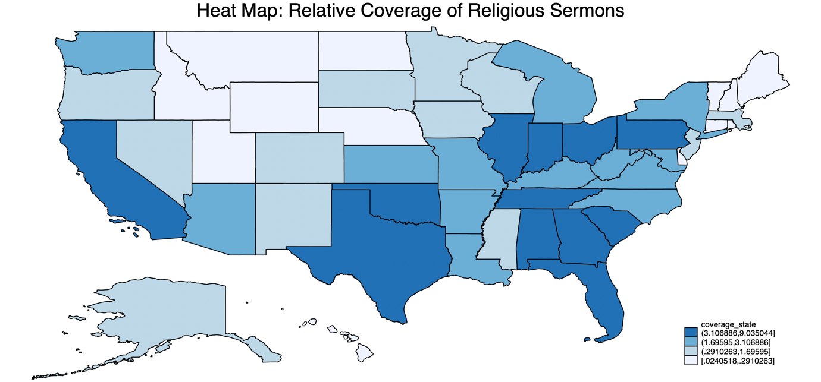

### State: Adjusted Relative Coverage

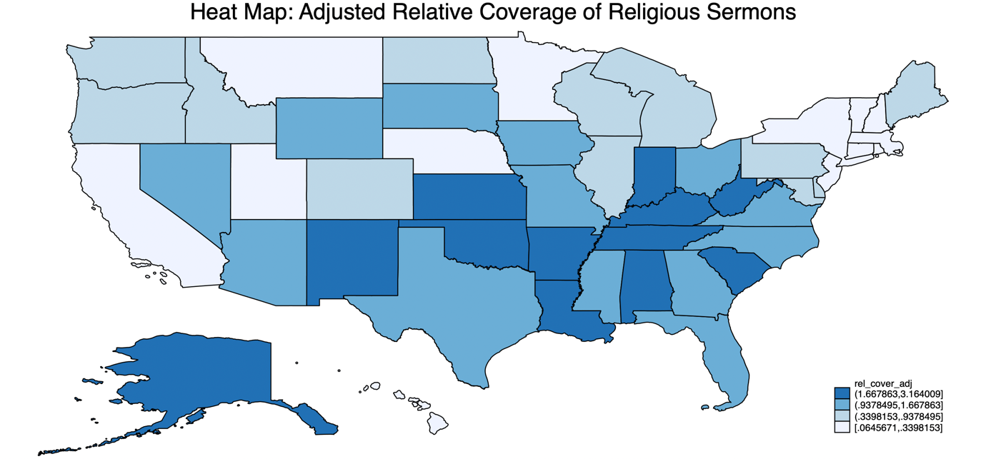

### Election-Related Words

The words screened in religious sermons include: vote, voted, voting, ballot, candidate, nominate, elect, president, politician, politicians, re-vote.

#### RDD Style Graphs

##### Overlapping Graphs for All Election years: 12 months before & after election



##### Overlapping Graphs for All Election years: 4 weeks before & after election

##### 

##### Overlapping Graphs for Non-Election years: 4 weeks before & after the Tuesday between 2nd and 8th November



##### 2004 Election: George Bush and John Kerry



##### 2008 Election: John McCain and Barack Obama



##### 2012 Election: Mitt Romney and Barack Obama



##### 2016 Election: Donald Trump and Hilary Clinton



##### 2020 Election: Donald Trump and Joe Biden



#### Word Count Graph



### Presidential Election Candidates’ Mentions

The words screened include: George W. Bush, John Kerry, George Bush, kerry, george bush, Barack Obama, John McCain, obama, john mccain, John Mccain, President obama, barack, Mitt Romney, mitt romney, romney, Donald Trump, Hillary Clinton, Clinton, hillary, donald, Joe Biden, biden, President Bush, President Obama, President Trump, President Biden

#### RDD style graphs

##### Overlapping Graphs for All Election years: 12 months before & after election



##### Overlapping Graphs for All Election years: 4 weeks before & after an election



##### Overlapping Graphs for Non-Election years: 4 weeks before & after Tuesday between 2nd and 8th November.



##### 2004 Election: George Bush and John Kerry



##### 2008 Election: John McCain and Barack Obama



##### 2012 Election: Mitt Romney and Barack Obama



##### 2016 Election: Donald Trump and Hilary Clinton



##### 2020 Election: Donald Trump and Joe Biden



#### Word Count Graph



### RDD-Style Graphs: Sermon Count and View Count

#### Count of Sermons: 4 weeks before and after the nearest election



#### Count of Sermons: 12 months before and after the nearest election



#### Total Views of Sermons: 4 weeks before and after the nearest election



#### Total Views of Sermons: 12 months before and after the nearest election



## Pastor-Level Controls

|  |  |  |  |  |  |  |  |  |  |
| --- | --- | --- | --- | --- | --- | --- | --- | --- | --- |
| **Variables** | **Obs** | **Mean** | **Std. Dev.** | **Min** | **Max** | **p1** | **p99** | **Skew.** | **Kurt.** |
| married0 | 163056 | 0.487 | 0.5 | 0 | 1 | 0 | 1 | 0.052 | 1.003 |
| married | 83097 | 0.955 | 0.208 | 0 | 1 | 0 | 1 | -4.381 | 20.195 |
| children0 | 140606 | 1.117 | 1.71 | 0 | 9 | 0 | 7 | 1.475 | 4.659 |
| children | 57918 | 2.737 | 1.654 | 0 | 9 | 0 | 8 | 0.562 | 3.858 |
| edu theology0 | 163761 | 0.107 | 0.309 | 0 | 1 | 0 | 1 | 2.541 | 7.455 |
| edu theology | 103345 | 0.167 | 0.373 | 0 | 1 | 0 | 1 | 1.79 | 4.204 |
| edu theological0 | 163761 | 0.283 | 0.451 | 0 | 1 | 0 | 1 | 0.962 | 1.925 |
| edu theological | 103345 | 0.446 | 0.497 | 0 | 1 | 0 | 1 | 0.218 | 1.047 |
| edu0 | 144946 | 1.675 | 1.533 | 0 | 4 | 0 | 4 | 0.069 | 1.41 |
| edu | 84542 | 2.872 | 0.768 | 1 | 4 | 1 | 4 | -0.104 | 2.355 |
| denom index | 164133 | 15.923 | 10.728 | 1 | 39 | 1 | 39 | 0.536 | 1.904 |
| family index | 164133 | 9.547 | 5.178 | 1 | 16 | 3 | 16 | -0.298 | 1.363 |
| exp bin | 8765 | 26.826 | 12.317 | 10 | 60 | 10 | 50 | 0.409 | 2.332 |
|  | | | | | | | | | |

The explanation behind the variables and their construction can be explained below:

### Married0

**Married0** is a binary (dummy) variable that takes the value **1** if the pastor is married and **0** if the pastor is not married.

To construct this variable, the following steps were followed:

**Step 1: Identifying Relevant Text Fields**

To determine a pastor’s marital status, text from the following variables was screened:

* **'family'**
* **'whatmyspousereallythinksofmyserm'**
* **'experience'**

**Step 2: Keyword Matching**

The classification was based on specific keywords found in these text fields:

**Indications of being married** (assigned **1**):

Words searched in sermons: *wife, husband, married, spouse, helpmate, marriage, casado*

**Indications of being unmarried** (assigned **0**):

Words searched in sermons: *widow, widower, girlfriend, I am single*

**Step 3: Handling Missing Data**

Pastors who did **not** respond to *'whatmyspousereallythinksofmyserm'* and *‘family’* were automatically classified as unmarried (coded as **0**).

**Step 4: Manual Review & Adjustments**

Following the automated classification, a manual review was conducted to validate and refine the variable. A random sample of 10 observations from pastors whose marital status remained unclassified (i.e., not coded as 0 or 1) was drawn. These observations were individually examined to assess whether they were correctly left unclassified. Where appropriate, pastors were manually recoded as married (1), unmarried (0), or missing (.). This process involved using the *strpos* string function to identify relevant keywords in the text fields and ensure more accurate classification. After reviewing the initial 10 observations, the process was repeated iteratively 20 times.

**Married**: The 'married' variable is the same as the 'married0' variable except that pastors who do not respond to the '*whatmyspousereallythinksofmyserm*' variable are treated as missing observations instead of being coded as unmarried (coded as '.').

**Step 5: Plotting Married0 and Married against ‘week_to_nearest_election’**





### Children0:

Children0 is a variable for the number of children a pastor has, ranging from 0 to 9.

To construct this variable, the following steps were followed:

**Step 1: Identifying Relevant Text Fields**

To determine the number of children a pastor has, information was extracted from the ‘family’ variable.

**Step 2: Keyword Matching**

The classification was based on specific keywords found in these text fields, by using commonly used phrases to describe number of children to build the variable.

**Indication that a pastor has no kids** (assigned children = 0):

Words searched in sermons:

* *we don’t have children, we don't have any children, i don’t have children, i don't have any children*
* *no kids, no children*
* *just me and my wife, just me and my husband, just my wife and me, just my husband and me, it’s just the two of us, just my wife, just my husband, just my parents*

**Indication that a pastor has one child** (assigned children = 1):

Words searched in sermons:

* *one child, 1 child, one kid, 1 kid*
* *one grown child, 1 grown child, one grown kid, 1 grown kid, one adult child, 1 adult child, one adult kid, 1 adult kid, one married child, 1 married child, one married kid, 1 married kid, one beautiful child, 1 beautiful child, one beautiful kid, 1 beautiful kid, one wonderful child, 1 wonderful child, one wonderful kid, 1 wonderful kid, one great child, 1 great child, one great kid, 1 great kid, one terrific kid, 1 terrific kid*
* *one son, 1 son, one boy, 1 boy, one daughter, 1 daughter, one girl, 1 girl, our only child, first and only child, our one child, our 1 child*
* *one adult son, 1 adult son, one adult daughter, 1 adult daughter, one married son, 1 married son, one married daughter, 1 married daughter, one grown son, 1 grown son, one grown daughter, 1 grown daughter, one beautiful son, 1 beautiful son, one beautiful daughter, 1 beautiful daughter, one wonderful son, 1 wonderful son, one wonderful daughter, 1 wonderful daughter, one amazing son, 1 amazing son, one amazing daughter, 1 amazing daughter, one great son, 1 great son, one great daughter, 1 great daughter, one terrific son, 1 terrific son, one terrific daughter, 1 terrific daughter*
* *1 stepson, one stepson, 1 stepdaughter, one stepdaughter*

**Indication that a pastor has two children** (assigned children = 2):

Words searched in sermons:

* *two children, 2 children, two kids, 2 kids*
* *two grown children, 2 grown children, , two grown kids, 2 grown kids, two adult children, 2 adult children, two adult kids, 2 adult kids, two married children, 2 married children, two married kids, 2 married kids, two beautiful children, 2 beautiful children, two beautiful kids, 2 beautiful kids, two wonderful children, 2 wonderful children, two wonderful kids, 2 wonderful kids, two amazing children, 2 amazing children, two amazing kids, 2 amazing kids, two great children, 2 great children, two great kids, 2 great kids, two terrific children, 2 terrific children, two terrific kids, 2 terrific kids*
* *two sons, 2 sons, two boys, 2 boys, two daughters, 2 daughters, two girls, 2 girls, one son and one daughter, a son and a daughter, 1 son and 1 daughter, one daughter and one son, a daughter and a son, 1 daughter and 1 son*
* *two adult sons, 2 adult sons, two adult daughters, 2 adult daughters, two married sons, 2 married sons, two married daughters, 2 married daughters, two grown-up sons, 2 grown-up sons, two grown-up daughters, 2 grown-up daughters, two beautiful sons, 2 beautiful sons, two beautiful daughters, 2 beautiful daughters, two wonderful sons, 2 wonderful sons, two wonderful daughters, 2 wonderful daughters, two amazing sons, 2 amazing sons, two amazing daughters, 2 amazing daughters, two great sons, 2 great sons, two great daughters, 2 great daughters, two terrific sons, 2 terrific sons, two terrific daughters, 2 terrific daughters*
* *two stepchildren, 2 stepchildren*

**Indication that a pastor has three children** (assigned children = 3):

Words searched in sermons:

* *three children, 3 children, three kids, 3 kids*
* *three grown children, 3 grown children, , three grown kids, 3 grown kids, three adult children, 3 adult children, three adult kids, 3 adult kids, three married children, 3 married children, three married kids, 3 married kids, three beautiful children, 3 beautiful children, three beautiful kids, 3 beautiful kids, three wonderful children, 3 wonderful children, three wonderful kids, 3 wonderful kids, three amazing children, 3 amazing children, three amazing kids, 3 amazing kids, three great children, 3 great children, three great kids, 3 great kids, three terrific children, 3 terrific children, three terrific kids, 3 terrific kids*
* *three sons, 3 sons, three boys, 3 boys, three daughters, 3 daughters, three girls, 3 girls, one son and two daughters, 1 son and 2 daughters, a son and two daughters, a son and 2 daughters, two sons and one daughter, 2 sons and 1 daughter, two sons and a daughter, 2 sons and a daughter, one daughter and two sons, 1 daughter and 2 sons, a daughter and two sons, a daughter and 2 sons, two daughters and one son, 2 daughters and 1 son, two daughters and a son, 2 daughters and a son*
* *three adult sons, 3 adult sons, three adult daughters, 3 adult daughters, three married sons, 3 married sons, three married daughters, 3 married daughters, three grown-up sons, 3 grown-up sons, three grown-up daughters, 3 grown-up daughters, three beautiful sons, 3 beautiful sons, three beautiful daughters, 3 beautiful daughters, three wonderful sons, 3 wonderful sons, three wonderful daughters, 3 wonderful daughters, three amazing sons, 3 amazing sons, three amazing daughters, 3 amazing daughters, three great sons, 3 great sons, three great daughters, 3 great daughters, three terrific sons, 3 terrific sons, three terrific daughters, 3 terrific daughters*
* *three stepchildren, 3 stepchildren*

**Indication that a pastor has four children** (assigned children = 4):

Words searched in sermons:

* *four children, 4 children, four kids, 4 kids*
* *four grown children, 4 grown children, , four grown kids, 4 grown kids, four adult children, 4 adult children, four adult kids, 4 adult kids, four married children, 4 married children, four married kids, 4 married kids, four beautiful children, 4 beautiful children, four beautiful kids, 4 beautiful kids, four wonderful children, 4 wonderful children, four wonderful kids, 4 wonderful kids, four amazing children, 4 amazing children, four amazing kids, 4 amazing kids, four great children, 4 great children, four great kids, 4 great kids, four terrific children, 4 terrific children, four terrific kids, 4 terrific kids*
* *four sons, 4 sons, four boys, 4 boys, four daughters, 4 daughters, four girls, 4 girls, one son and three daughters, 1 son and 3 daughters, a son and three daughters, a son and 3 daughters, two sons and two daughters, 2 sons and 2 daughters, three sons and one daughter, 3 sons and 1 daughter, three sons and a daughter, 3 sons and a daughter, one daughter and three sons, 1 daughter and 3 sons, a daughter and three sons, a daughter and 3 sons, three daughters and one son, 3 daughters and 1 son, three daughters and one son, three daughters and a son, 3 daughters and a son*
* *four adult sons, 4 adult sons, four adult daughters, 4 adult daughters, four married sons, 4 married sons, four married daughters, 4 married daughters, four grown-up sons, 4 grown-up sons, four grown-up daughters, 4 grown-up daughters, four beautiful sons, 4 beautiful sons, four beautiful daughters, 4 beautiful daughters, four wonderful sons, 4 wonderful sons, four wonderful daughters, 4 wonderful daughters, four amazing sons, 4 amazing sons, four amazing daughters, 4 amazing daughters, four great sons, 4 great sons, four great daughters, 4 great daughters, four terrific sons, 4 terrific sons, four terrific daughters, 4 terrific daughters*
* *four stepchildren, 4 stepchildren*

**Indication that a pastor has five children** (assigned children = 5):

Words searched in sermons:

* *five children, 5 children, five kids, 5 kids*
* *five grown children, 5 grown children, , five grown kids, 5 grown kids, five adult children, 5 adult children, five adult kids, 5 adult kids, five married children, 5 married children, five married kids, 5 married kids, five beautiful children, 5 beautiful children, five beautiful kids, 5 beautiful kids, five wonderful children, 5 wonderful children, five wonderful kids, 5 wonderful kids, five amazing children, 5 amazing children, five amazing kids, 5 amazing kids, five great children, 5 great children, five great kids, 5 great kids, five terrific children, 5 terrific children, five terrific kids, 5 terrific kids*
* *five sons, 5 sons, five boys, 5 boys, five daughters, 5 daughters, five girls, 5 girls*
* *one son and four daughters, 1 son and 4 daughters, a son and four daughters, a son and 4 daughters, two sons and three daughters, 2 sons and 3 daughters, three sons and two daughters, 3 sons and 2 daughters, four sons and one daughter, 4 sons and 1 daughter, one daughter and four sons, 1 daughter and 4 sons, a daughter and four sons, a daughter and 4 sons, two daughters and three sons, 2 daughters and 3 sons, three daughters and two sons, 3 daughters and 2 sons, four daughters and one son, 4 daughters and 1 son, four daughters and a son, 4 daughters and a son*
* *five adult sons, 5 adult sons, five adult daughters, 5 adult daughters, five married sons, 5 married sons, five married daughters, 5 married daughters, five grown-up sons, 5 grown-up sons, five grown-up daughters, 5 grown-up daughters, five beautiful sons, 5 beautiful sons, five beautiful daughters, 5 beautiful daughters, five wonderful sons, 5 wonderful sons, five wonderful daughters, 5 wonderful daughters, five amazing sons, 5 amazing sons, five amazing daughters, 5 amazing daughters, five great sons, 5 great sons, five great daughters, 5 great daughters, five terrific sons, 5 terrific sons, five terrific daughters, 5 terrific daughters*
* *five stepchildren, 5 stepchildren*

**Indication that a pastor has six children** (assigned children = 6):

Words searched in sermons:

* *six children, 6 children, six kids, 6 kids*
* *six grown children, 6 grown children, , six grown kids, 6 grown kids, six adult children, 6 adult children, six adult kids, 6 adult kids, six married children, 6 married children, six married kids, 6 married kids, six beautiful children, 6 beautiful children, six beautiful kids, 6 beautiful kids, six wonderful children, 6 wonderful children, six wonderful kids, 6 wonderful kids, six amazing children, 6 amazing children, six amazing kids, 6 amazing kids, six great children, 6 great children, six great kids, 6 great kids, six terrific children, 6 terrific children, six terrific kids, 6 terrific kids*
* *six sons, 6 sons, six boys, 6 boys, six daughters, 6 daughters, six girls, 6 girls,*
* *one son and five daughters, 1 son and 5 daughters, a son and five daughters, a son and 5 daughters, two sons and four daughters, 2 sons and 4 daughters, three sons and three daughters, 3 sons and 3 daughters, four sons and two daughters, 4 sons and 2 daughters, five sons and one daughter, 5 sons and 1 daughter, 5 sons and a daughter, five sons and a daughter, one daughter and five sons, 1 daughter and 5 sons, a daughter and five sons, a daughter and 5 sons, two daughters and four sons, 2 daughters and 4 sons, three daughters and three sons, 3 daughters and 3 sons, four daughters and two sons, 4 daughters and 2 sons, 5 daughters and 1 son, five daughters and one son, five daughters and a son, 5 daughters and a son*
* *six adult sons, 6 adult sons, six adult daughters, 6 adult daughters, six married sons, 6 married sons, six married daughters, 6 married daughters, six grown-up sons, 6 grown-up sons, six grown-up daughters, 6 grown-up daughters, six beautiful sons, 6 beautiful sons, six beautiful daughters, 6 beautiful daughters, six wonderful sons, 6 wonderful sons, six wonderful daughters, 6 wonderful daughters, six amazing sons, 6 amazing sons, six amazing daughters, 6 amazing daughters, six great sons, 6 great sons, six great daughters, 6 great daughters, six terrific sons, 6 terrific sons, six terrific daughters, 6 terrific daughters*
* *six step-children, 6 stepchildren*

**Indication that a pastor has seven children** (assigned children = 7):

Words searched in sermons:

* *seven children, 7 children, seven kids, 7 kids*
* *seven grown children, 7 grown children, , seven grown kids, 7 grown kids, seven adult children, 7 adult children, seven married children, 7 married children, seven married kids, 7 married kids, seven adult kids, 7 adult kids, seven beautiful children, 7 beautiful children, seven wonderful children, 7 wonderful children, seven amazing kids, 7 amazing kids, seven great kids, 7 great kids, seven terrific kids, 7 terrific kids,*
* *seven sons, 7 sons, seven boys, 7 boys, seven daughters, 7 daughters, seven girls, 7 girls*
* *one son and six daughters, 1 son and 6 daughters, a son and six daughters, a son and 6 daughters, two sons and five daughters, 2 sons and 5 daughters, three sons and four daughters, 3 sons and 4 daughters, four sons and three daughters, 4 sons and 3 daughters, five sons and two daughters, 5 sons and 2 daughters, six sons and one daughter, 6 sons and 1 daughter, six sons and a daughter, 6 sons and a daughter, one daughter and six sons, 1 daughter and 6 sons, a daughter and six sons, a daughter and 6 sons, two daughters and five sons, 2 daughters and 5 sons, three daughters and four sons, 3 daughters and 4 sons, four daughters and three sons, 4 daughters and 3 sons, five daughters and two sons, 5 daughters and 2 sons, six daughters and one son, 6 daughters and 1 son, 6 daughters and a son, six daughters and a son*
* *seven adult sons, 7 adult sons, seven adult daughters, 7 adult daughters, seven married sons, 7 married sons, seven married daughters, 7 married daughters, seven grown-up sons, 7 grown-up sons, seven grown-up daughters, 7 grown-up daughters, seven beautiful sons, 7 beautiful sons, seven beautiful daughters, 7 beautiful daughters, seven wonderful sons, 7 wonderful sons, seven wonderful daughters, 7 wonderful daughters, seven amazing sons, 7 amazing sons, seven amazing daughters, 7 amazing daughters, seven great sons, 7 great sons, seven great daughters, 7 great daughters, seven terrific sons, 7 terrific sons, seven terrific daughters, 7 terrific daughters*
* *seven step-children, 7 step-children*

**Indication that a pastor has eight children** (assigned children = 8):

Words searched in sermons:

* *eight children, 8 children, eight kids, 8 kids*
* *eight grown children, 8 grown children, , eight grown kids, 8 grown kids, eight adult children, 8 adult children, eight adult kids, 8 adult kids, eight married children, 8 married children, eight married kids, 8 married kids, eight beautiful children, 8 beautiful children, eight beautiful kids, 8 beautiful kids, eight wonderful children, 8 wonderful children, eight wonderful kids, 8 wonderful kids, eight amazing children, 8 amazing children, eight amazing kids, 8 amazing kids, eight great children, 8 great children, eight great kids, 8 great kids, eight terrific children, 8 terrific children, eight terrific kids, 8 terrific kids*
* *eight sons, 8 sons, eight boys, 8 boys, eight daughters, 8 daughters, eight girls, 8 girls,*
* *one son and seven daughters, 1 son and 7 daughters, a son and seven daughters, a son and 7 daughters, two sons and six daughters, 2 sons and 6 daughters, three sons and five daughters, 3 sons and 5 daughters, four sons and four daughters, 4 sons and 4 daughters, five sons and three daughters, 5 sons and 3 daughters, six sons and two daughters, 6 sons and 2 daughters, seven sons and one daughter, 7 sons and 1 daughter, 7 sons and a daughter, seven sons and a daughter, one daughter and seven sons, 1 daughter and 7 sons, a daughter and seven sons, a daughter and 7 sons, , two daughters and six sons, 2 daughters and 6 sons, three daughters and five sons, 3 daughters and 5 sons, four daughters and four sons, 4 daughters and 4 sons, five daughters and three sons, 5 daughters and 3 sons, six daughters and two sons, 6 daughters and 2 sons, seven daughters and one son, 7 daughters and 1 son, 7 daughters and a son, seven daughters and a son*
* *eight adult sons, 8 adult sons, eight adult daughters, 8 adult daughters, eight married sons, 8 married sons, eight married daughters, 8 married daughters, eight grown-up sons, 8 grown-up sons, eight grown-up daughters, 8 grown-up daughters, eight beautiful sons, 8 beautiful sons, eight beautiful daughters, 8 beautiful daughters, eight wonderful sons, 8 wonderful sons, eight wonderful daughters, 8 wonderful daughters, eight amazing sons, 8 amazing sons, eight amazing daughters, 8 amazing daughters, eight great sons, 8 great sons, eight great daughters, 8 great daughters, eight terrific sons, 8 terrific sons, eight terrific daughters, 8 terrific daughters*
* *eight step-children, 8 step-children*

**Indication that a pastor has nine children** (assigned children = 9):

Words searched in sermons:

* *nine children, 9 children, nine kids, 9 kids*
* *nine grown children, 9 grown children, , nine grown kids, 9 grown kids, nine adult children, 9 adult children, nine adult kids, 9 adult kids, nine married children, 9 married children, nine married kids, 9 married kids, nine beautiful children, 9 beau-tiful children, nine beautiful kids, 9 beautiful kids, nine wonderful children, 9 won-derful children, nine wonderful kids, 9 wonderful kids, nine amazing children, 9 amazing children, nine amazing kids, 9 amazing kids, nine great children, 9 great children, nine great kids, 9 great kids, nine terrific children, 9 terrific children, nine terrific kids, 9 terrific kids*
* *nine sons, 9 sons, nine boys, 9 boys, nine daughters, 9 daughters, nine girls, 9 girls*
* *one son and eight daughters, 1 son and 8 daughters, a son and eight daughters, a son and 8 daughters, two sons and seven daughters, 2 sons and 7 daughters, three sons and six daughters, 3 sons and 6 daughters, four sons and five daughters, 4 sons and 5 daughters, five sons and four daughters, 5 sons and 4 daughters, six sons and three daughters, 6 sons and 3 daughters, seven sons and two daughters, 7 sons and 2 daughters, eight sons and one daughter, 8 sons and 1 daughter, eight sons and a daughter, 8 sons and a daughter, one daughter and eight sons, 1 daughter and 8 sons, a daughter and eight sons, a daughter and 8 sons, two daughters and seven sons, 2 daughters and 7 sons, three daughters and six sons, 3 daughters and 6 sons, four daughters and five sons, 4 daughters and 5 sons, five daughters and four sons, 5 daughters and 4 sons, six daughters and three sons, 6 daughters and 3 sons, seven daughters and two sons, 7 daughters and 2 sons, eight daughters and one son, 8 daughters and one son, eight daughters and a son, 8 daughters and a son.*
* *nine adult sons, 9 adult sons, nine adult daughters, 9 adult daughters, nine married sons, 9 married sons, nine married daughters, 9 married daughters, nine grown-up sons, 9 grown-up sons, nine grown-up daughters, 9 grown-up daughters, nine beautiful sons, 9 beautiful sons, nine beautiful daughters, 9 beautiful daughters, nine wonderful sons, 9 wonderful sons, nine wonderful daughters, 9 wonderful daughters, nine amazing sons, 9 amazing sons, nine amazing daughters, 9 amazing daughters, nine great sons, 9 great sons, nine great daughters, 9 great daughters, nine terrific sons, 9 terrific sons, nine terrific daughters, 9 terrific daughters*
* *nine step-children, 9 step-children*

**Step 3: Handling Missing Data**

To ensure accuracy, pastors who did **not** respond to *'family'* were automatically classified as having no children (coded as **0**).

**Children**: The 'children' variable is the same as the 'children0' variable except that pastors who do not respond to the '*family*' variable are treated as missing observations instead of being coded as not having a family (coded as '.').

**Step 4: Plotting Children0 and Children against ‘week_to_nearest_election’**





### Edu theology0:

Edu theology0 is a binary (dummy) variable that takes the value **1** if the pastor has a degree in theology, and 0 if the pastor has does not have a degree in theology.

To construct this variable, the following steps were followed:

**Step 1: Identifying Relevant Text Fields**

To determine whether a pastor pursued a degree in theology, information was extracted from the ‘education’ variable.

**Step 2: Keyword Matching**

The classification was based on specific keywords found in the text field of ‘education’

**Indications of having a degree in theology** (assigned **1**):

Words searched in sermons: *Theology, Th.M, ThD, Master of Theology, MTh, BTh, Th.D*

**Indications of not having a degree in theology** (assigned **0**):

All other observations which did not contain the words indicative of a theological degree were coded as 0. This included pastors who studied non-theology courses at theological institute at university.

**Step 3: Handling Missing Data**

To ensure accuracy, pastors who did **not** respond to *'education'* were automatically classified as having no degree in theology (coded as **0**).

**Edu theology**: The 'edu theology' variable is the same as the 'edu theology0' variable except that pastors who do not respond to the '*education*' variable are treated as missing observations instead of being coded as not having a degree in theology(coded as '.').

**Step 4: Plotting Edu_theology0 and Edu_theology against ‘week_to_nearest_election’**





### Edu theological0:

Edu theological0 is a binary (dummy) variable that takes the value 1 if the pastor studied at a theological institution or department, or 0 otherwise.

**Note:** The variable Edu theological also includes the pastors which pursued a degree in theology (from the variable edu theology)

To construct this variable, the following steps were followed:

**Step 1: Identifying Relevant Text Fields**

To determine whether a pastor pursued a degree from a theological institute, information was extracted from the ‘education’ variable.

**Step 2: Keyword Matching**

The classification was based on specific keywords found in the text field of ‘education’

**Indications of having a degree at a theological institute** (assigned **1**):

Words searched in sermons: *Theology, Th.M, ThD, Master of Theology, MTh, BTh, Th.D, theological*

**Indications of not having a degree at a theological institute** (assigned **0**):

All other observations which did not contain the words indicative of a degree at a theological institute were coded as 0.

**Step 3: Handling Missing Data**

To ensure accuracy, pastors who did **not** respond to *'education'* were automatically classified as having no degree at a theological institute (coded as **0**).

**Edu theological**: The 'Edu theological' variable is the same as the 'Edu theological0' variable except that pastors who do not respond to the '*education*' variable are treated as missing observations instead of being coded as not having a degree from a theological institute (coded as '.').

**Step 4: Plotting Edu_theological0 and Edu_theological against ‘week_to_nearest_election’**



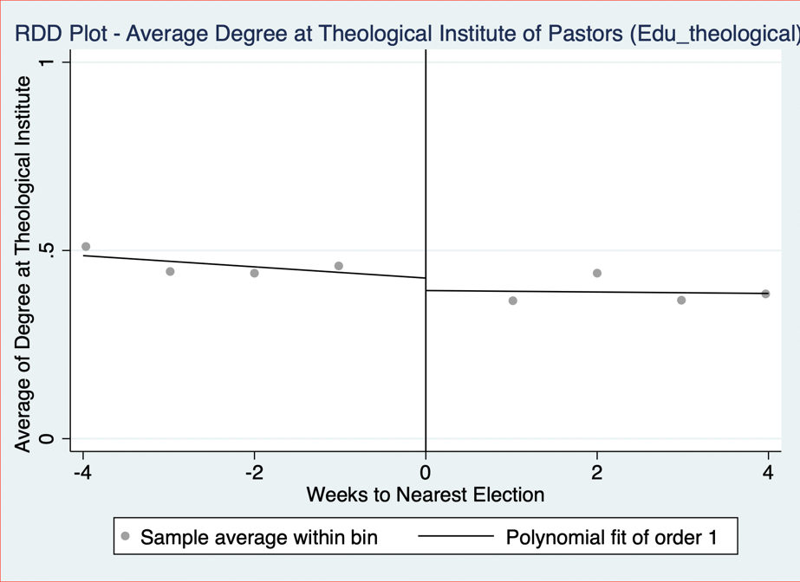

### Edu0:

Edu0 is a categorical variable for the level of education a pastor has, where:

* 1 = high school degree
* 2 = bachelor’s degree
* 3 = master’s degree
* 4 = PhD

To construct this variable, the following steps were followed:

**Step 1: Identifying Relevant Text Fields**

To determine a pastor’s level of education, information was extracted from the ‘education’ variable.

**Step 2: Keyword Matching**

The classification was based on specific keywords found in the ‘education; text field, by using commonly used phrases to describe education level to build the variable.

**Indication that a pastor has a high-school diploma (coded as 1):**

Words searched in sermons: *High School, HS diploma, school degree, Eagle Academy, Associate of Arts*

**Indication that a pastor has a bachelor’s degree (coded as 2):**

Words searched in sermons: *Bachelor, Bachelors, BA, BSC, undergraduate, B.A., Bachelor of Art, BS, B.S., BTh, Business Degree,*

**Indication that a pastor has a master’s degree (coded as 3):**

Words searched in sermons: *Masters*, *Th.M, Master of Theology, MTh, M.Div, Master, MA, MDiv, MOM.Div., M A, MAOM*

**Indication that a pastor has a PhD (coded as 4):**

Words searched in sermons: *PhD, Doctorate, Doctor of, Th.D, ThD*

**Note:** Pastors with Associate of Arts degrees were classified as having a high school diploma, even though an AA degree is higher than a high school diploma but lower than a bachelor's degree. This classification was made due to its equivalence to the first or second year of a bachelor's program.

**Step 3: Handling Missing Data**

To ensure accuracy, pastors who did **not** respond to *'education'* were automatically classified as having no education (coded as **0**).

**Step 4: Manual Review & Adjustments**

Following the automated classification, a manual review was conducted to validate and refine the education variable. A random sample of 10 observations from pastors whose education level remained unclassified (i.e., not yet coded) was drawn. These cases were individually examined to assess whether they were correctly left unclassified. Where appropriate, pastors were manually recoded based on the highest level of education identified. This process involved using the strpos string function to detect relevant educational keywords in the text fields, ensuring more consistent and accurate classification. After reviewing the initial 10 observations, the process was repeated iteratively 20 times.

**Edu**: The 'edu' variable is the same as the 'edu0' variable except that pastors who do not respond to the '*education*' variable are treated as missing observations instead of being coded as not having an education (coded as '.').

**Step 5: Plotting Edu0 and Edu against ‘week_to_nearest_election’**





### Denom_index:

Denom_Index is a numerical variable representing the religious denomination of the pastor. It assigns a numerical index to each denomination, as listed in Section 1.3.

**Denominations with High Relative Coverage**

To take a closer look at the denomination of Pastors, separate dummy variables were created for the ‘Baptist’, ‘Evangelical/Non-Denominational’, and ‘Christian/Church of Christ’ denominations. All other denominations were grouped together under a binary variable labeled ‘OtherDenom’. Descriptive statistics for these variables are presented below.

|  |  |  |  |  |  |  |  |  |  |
| --- | --- | --- | --- | --- | --- | --- | --- | --- | --- |
| **Variables** | **Obs** | **Mean** | **Std. Dev.** | **Min** | **Max** | **p1** | **p99** | **Skew.** | **Kurt.** |
| Baptist | 164133 | 0.333 | 0.471 | 0 | 1 | 0 | 1 | 0.707 | 1.499 |
| Evangelical | 164133 | 0.115 | 0.319 | 0 | 1 | 0 | 1 | 2.418 | 6.848 |
| ChurchofChrist | 164133 | 0.105 | 0.307 | 0 | 1 | 0 | 1 | 2.571 | 7.612 |
| OtherDenom | 164133 | 0.447 | 0.497 | 0 | 1 | 0 | 1 | 0.215 | 1.046 |
|  | | | | | | | | | |

**Checking for Smoothness in High-Relative-Coverage Denominations:**

The RDD-style graphs for Baptist, Evangelical/Non-Denominational, and Christian/Church of Christ pastors, as well as pastors from all other denominations, are presented below.

 

 

### Family_index:

Family_index is a numerical variable representing the religious family of the pastor. It assigns a numerical index to each religious family, as listed in Section ‎1.4. To clarify the distinction between denomination and religious family: denominations were self-reported by pastors and provide a more detailed, granular classification. Religious families, on the other hand, group these denominations into broader categories based on ARDA’s classifications.

**Religious Families with High Relative and High Adjusted Relative Coverage**

To take a closer look at the religious families of Pastors, separate dummy variables were created for the ‘Baptist’ and ‘Pentecostal’ families which had a high relative coverage and for the ‘Froehlich’ Family which had a High Adjusted Relative Coverage. All other religious families were grouped together under a binary variable labeled ‘OtherFam’. Descriptive statistics for these variables are presented below.

|  |  |  |  |  |  |  |  |  |  |
| --- | --- | --- | --- | --- | --- | --- | --- | --- | --- |
| **Variables** | **Obs** | **Mean** | **Std. Dev.** | **Min** | **Max** | **p1** | **p99** | **Skew.** | **Kurt.** |
| Baptist Family | 164133 | .333 | .471 | 0 | 1 | 0 | 1 | .707 | 1.499 |
| Pentecostal Family | 164133 | .155 | .361 | 0 | 1 | 0 | 1 | 1.912 | 4.654 |
| Froehlich Family | 164133 | .018 | .132 | 0 | 1 | 0 | 1 | 7.328 | 54.694 |
| OtherFam | 164133 | .494 | .5 | 0 | 1 | 0 | 1 | .022 | 1 |
|  | | | | | | | | | |

**Checking for Smoothness in High (Adjusted) Relative Coverage Religious Families:**

The RDD-style graphs for pastors from Baptist, Pentecostal, and Froehlich religious families, as well as pastors from all other religious families, are presented below.

 

 

### Exp bin:

Exp bin is a categorical variable for the level of experience of the pastor has, binned into the following categories:

* 10: from 0-10 years of experience
* 20: from 11-20 years of experience
* 30: from 21-30 years of experience
* 40: from 31-40 years of experience
* 50: from 41-50 years of experience
* 60: 51+ years of experience

To construct this variable, the following steps were followed:

**Step 1: Identifying Relevant Text Fields**

To determine a pastor’s level of experience, information was extracted from the ‘experience’ variable.

**Step 2: Manual Review**

Since the responses in the experience variable were highly heterogeneous, approximately 19,000 observations of the experience variable were manually coded. This process involved either:

* Directly extracting the number of years of experience provided by the pastor, or
* Applying the following method:
  + Extracting any dates mentioned by the pastor.
  + Comparing these dates to the sermon contribution date to calculate the total years of experience.
  + Assigning the corresponding experience bin based on the calculated number of years.

**Step 3: Using ChatGPT API to classify Exp Bin:**

To classify the exp_bin variable for all observations, the ChatGPT API was used to categorize all the sermons based on 400 manually coded observations. The process followed these steps:

1. Reference Set Creation:
   1. A sample of 400 manually coded observations was extracted to serve as reference examples.
   2. These examples demonstrated how pastors’ descriptions were mapped to experience bins.
2. Prompt Design:
   1. The system prompt included:
   2. The reference examples for pattern recognition.
   3. Rules for assigning experience bins based on mentioned years or inferred tenure. If pastors mention retirement from the military, GPT was instructed to add 20 years on top of their years of experience.
   4. If experience was missing or unclear, GPT was instructed to return a placeholder (".") rather than forcing a classification.
3. Processing with GPT:
   1. For each pastor, a structured input was created with:
      1. The unique id of the pastor
      2. Their experience field.
      3. Their latest sermon contribution date (to infer years of experience).
   2. The GPT model was queried with this information.
   3. The returned classifications were saved and merged with the main dataset.

**Step 4: Plotting Exp_Bin against ‘week_to_nearest_election’**



**Note of Discretion regarding Experience Coding:**

The classification of pastoral experience is based on self-reported information, which introduces several limitations. Some pastors reported overlapping church and non-church roles separately (e.g., serving part-time as a pastor while working another job), which may inflate their total years of pastoral service. In contrast, others focused solely on church-related roles and omitted relevant non-church experience, making comparisons across individuals more difficult. For retired military veterans, 20 years were added to their church-related experience to account for military service; however, actual lengths of service may differ from this standardized adjustment.

## Sentiment Analysis

Two sentiment models were used to analyse sermon text sentences mentioning presidential candidates. The sentences before and after were considered when classifying each mention to give more context to the sentiment of the statement – we refer to such a collection of sentences as a sentence block. The analysis was run on two datasets: one that contained sentence blocks that mention at least one candidate, and another that contained only sentence blocks that mention exactly one candidate. For sentence blocks that mention exactly one candidate, the analysis for Bill Clinton and Hillary Clinton captures only sentence blocks that contain “Bill Clinton” and “Hillary Clinton”, respectively, without discarding if the other is also mentioned. The analysis for Clinton captures sentence blocks that contain any of “Bill Clinton”, “Hillary Clinton”, or “Clinton” and can be thought of as the Clinton family. 240 of the 337 captured sentence blocks mention exactly one candidate.

**Positive/Negative Sentiment Analysis:**

The first model, distilbert-base-uncased-finetuned-sst-2-english, classified sentiment as positive or negative. The candidates were then ranked by their difference in percent of mentions labelled positive and percent of mentions labelled negative. The following outputs were produced.

At Least 1 Candidate Mentioned in Sentence Block:

Candidate Sentiment Ranking

|  |  |  |  |  |  |  |
| --- | --- | --- | --- | --- | --- | --- |
| Rank | Name | Party | Total Mentions | Pos % | Neg % | Pos - Neg % |
| 1 | Kerry | Democrat | 19 | 57.89 | 42.11 | 15.78 |
| 2 | Trump | Republican | 118 | 51.69 | 48.31 | 3.38 |
| 3 | Obama | Democrat | 124 | 45.16 | 54.84 | -9.68 |
| 4 | McCain | Republican | 36 | 44.44 | 55.56 | -11.12 |
| 5 | Bush | Republican | 51 | 43.14 | 56.86 | -13.72 |
| 6 | Clinton | Democrat | 60 | 36.67 | 63.33 | -26.66 |
| 7 | Bill Clinton | Democrat | 23 | 34.78 | 65.22 | -30.44 |
| 8 | Biden | Democrat | 22 | 27.27 | 72.73 | -45.46 |
| 9 | Hillary Clinton | Democrat | 10 | 20.00 | 80.00 | -60.00 |
| 10 | Romney | Republican | 13 | 15.38 | 84.62 | -69.24 |

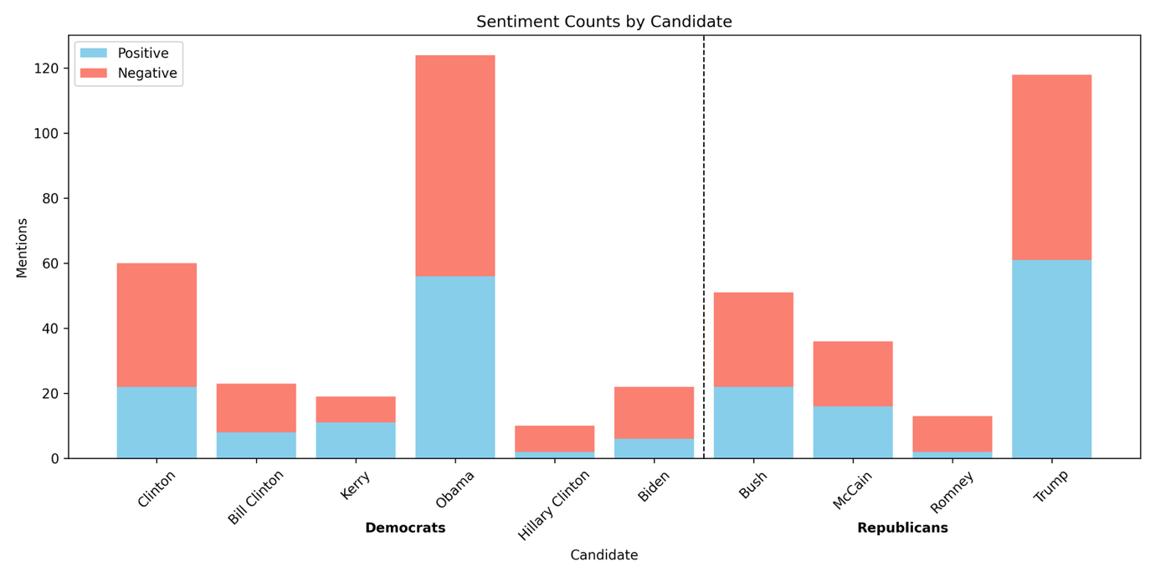

Top Sentence Blocks per Candidate

|  |  |  |
| --- | --- | --- |
| Label | Candidate | Sentence Block |
| Negative | Biden | We must rely on the grace of Christ to carry us through, and His sacramental presence and consolation. What if it gets worse as Biden and Harris have promised it would and lasts for four years or eight or the rest of our lives, God forbid. The Ephesus church also had a third attaboy from St. |
| Negative | Bush | It's the Economy, Stupid. This buzz phrase become very popular during the first President Bush's administration, and could easily be used today. Today let's take a look at God's spiritual economic plan for His people. |
| Negative | Clinton | When reporters hounded him about Clintonian lies, Stephanopoulos accused them of an excess of literalism. Stephanopoulos, to his credit, did tire of the Clinton lies and left the White House. CHALLENGE:Finding the truth, and acting on it, is an old problem. |
| Negative | Bill Clinton | You're sitting there thinking You just told us that you have no idea what a perfect gift is... and now you are going to preach about what one is. That seems like listening to Mickey Rooney pontificate about the dangers of being tall or Roseanne speaking on morality Michael Jordan giving a seminar on How To Survive on A Limited Income, Bill Clinton on Honesty... or Frank Gifford on Marital Fidelity. Now, before you get testy and negative I want you to know I am not speaking from personal experience of from my own wisdom. |
| Negative | Hillary Clinton | 83 a year after taxes. Those opposed to Hillary Clinton will point out that as a First Lady, Senator, and Secretary of State she never accomplished anything. Many accuse her of having an open marriage, allowing her husband the freedom to have affairs. |
| Negative | Kerry | You'll be congratulated for all your hard work, and you'll probably be given a job in the government somewhere that's your reward, if you want it, for working on the campaign for the winner. But if you were on John Kerry's campaign staff, then election day for you is not a good day. All your work didn't result in what you had hoped. |
| Negative | McCain | You might think it would be a disaster. If your perspective is that John McCain is the right man to be our next president, then you might think that an Obama presidency is something to fear. If you have any money invested in the stock market, you've no doubt lost a lot of money in the past few months at least on paper. |
| Negative | Obama | This bad form, bad manners. It would be a little like Obama sending a White House page boy to greet Putin or the Queen of England. 5. |
| Negative | Romney | Conan O'Brien4. Today Mitt Romney visited a firehouse here in New York City. Of course, he was disappointed when he learned that the firehouse is not where you get to fire people. |
| Negative | Trump | Our nation will be in a mess. Those who oppose Trump declare that Islamic Mosques will be closed, inhibiting their freedom of religion. The press will be suppressed with only those in his favor getting access to him. |
| Positive | Biden | WILL WE TRUST HIM. BIDEN. TRUMP. |
| Positive | Bush | B. Following this bold tradition President Bush made the following proclamation concerning thanksgiving on November 21, 2008:Thanksgiving is a time for families and friends to gather together and express gratitude for all that we have been given, the freedoms we enjoy, and the loved ones who enrich our lives. We recognize that all of these blessings, and life itself, come not from the hand of man but from Almighty God. |
| Positive | Clinton | A good teacher inspires a thirst for learning that lasts a lifetime. Bill Clinton said that on August 5, 1993 during a ceremony honoring inductees into the teacher's Hall of Fame. Henry Brooks Adams said, Teachers affect eternity, they can never know the full range of their influence. |
| Positive | Bill Clinton | A good teacher inspires a thirst for learning that lasts a lifetime. Bill Clinton said that on August 5, 1993 during a ceremony honoring inductees into the teacher's Hall of Fame. Henry Brooks Adams said, Teachers affect eternity, they can never know the full range of their influence. |
| Positive | Hillary Clinton | I like to play golf. Hillary Clinton has been dealing with scandals concerning her husband for years. Bill Clinton has been publicly accused by several women of sexual misconduct. |
| Positive | Kerry | One of the candidates answered with a very strong religious statement. It wasn't George Bush because he answered, I don't know -It was Senator John Kerry who said - We're all God's children, he said. And I think if you were to talk to Dick Cheney's daughter, who is a lesbian, she would tell you that she's being who she was. |
| Positive | McCain | John McCain, you are a minister of God. Barack Obama, you are a minister of God. We must look for people to put into office who are moving closer to divine revelation from God. |
| Positive | Obama | And I do my very best to remember Him through His Son, Jesus Christ, and to focus on Him first and foremost in my life. Let us thank all of our veterans for their courageous service for America, and let us also remember to pray for our leaders, including President-elect Barrack Obama and his staff, that they might find themselves being led by God Almighty in their administration of this blessed nation. This is a time of healing and refocusing on our Lord, not a time of bitterness and negativity. |
| Positive | Romney | Jay Leno 6. Mitt Romney believes that marriage should be between one man and one woman. Which is better than his grandfather, who believed that it should be between one man and five women. |
| Positive | Trump | Psalm 72, NLT -Include in the bulletin for members:Dear Heavenly Father,I come before you with a humble and grateful heart. I ask you to lift up those who are seated in places of authority in our nation President Trump, those representing me in the United States Senate, in the U. S. |

Exactly 1 Candidate Mentioned in Sentence Block:

Candidate Sentiment Ranking

|  |  |  |  |  |  |  |
| --- | --- | --- | --- | --- | --- | --- |
| Rank | Name | Party | Total Mentions | Pos % | Neg % | Pos - Neg % |
| 1 | Kerry | Democrat | 10 | 60.00 | 40.00 | 20.00 |
| 2 | Trump | Republican | 83 | 56.63 | 43.37 | 13.26 |
| 3 | Bush | Republican | 26 | 53.85 | 46.15 | 7.70 |
| 4 | Obama | Democrat | 68 | 50.00 | 50.00 | 0.00 |
| 5 | McCain | Republican | 6 | 50.00 | 50.00 | 0.00 |
| 6 | Bill Clinton | Democrat | 18 | 38.89 | 61.11 | -22.22 |
| 7 | Clinton | Democrat | 35 | 37.14 | 62.86 | -25.72 |
| 8 | Romney | Republican | 4 | 25.00 | 75.00 | -50.00 |
| 9 | Biden | Democrat | 8 | 12.50 | 87.50 | -75.00 |
| 10 | Hillary Clinton | Democrat | 5 | 0.00 | 100.00 | -100.00 |

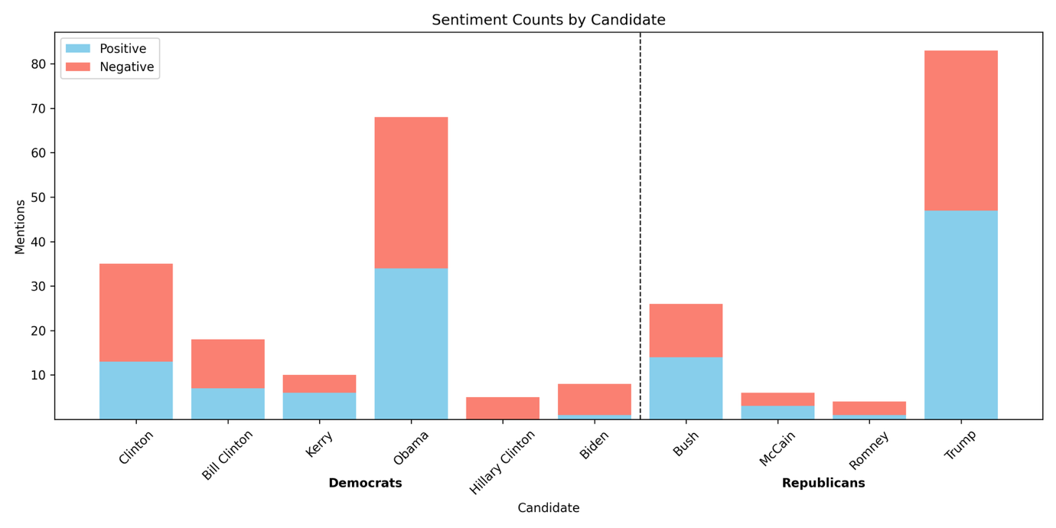

Top Sentence Blocks per Candidate

|  |  |  |
| --- | --- | --- |
| Label | Candidate | Sentence Block |
| Negative | Biden | We must rely on the grace of Christ to carry us through, and His sacramental presence and consolation. What if it gets worse as Biden and Harris have promised it would and lasts for four years or eight or the rest of our lives, God forbid. The Ephesus church also had a third attaboy from St. |
| Negative | Bush | It's the Economy, Stupid. This buzz phrase become very popular during the first President Bush's administration, and could easily be used today. Today let's take a look at God's spiritual economic plan for His people. |
| Negative | Clinton | When reporters hounded him about Clintonian lies, Stephanopoulos accused them of an excess of literalism. Stephanopoulos, to his credit, did tire of the Clinton lies and left the White House. CHALLENGE:Finding the truth, and acting on it, is an old problem. |
| Negative | Bill Clinton | You're sitting there thinking You just told us that you have no idea what a perfect gift is... and now you are going to preach about what one is. That seems like listening to Mickey Rooney pontificate about the dangers of being tall or Roseanne speaking on morality Michael Jordan giving a seminar on How To Survive on A Limited Income, Bill Clinton on Honesty... or Frank Gifford on Marital Fidelity. Now, before you get testy and negative I want you to know I am not speaking from personal experience of from my own wisdom. |
| Negative | Hillary Clinton | 83 a year after taxes. Those opposed to Hillary Clinton will point out that as a First Lady, Senator, and Secretary of State she never accomplished anything. Many accuse her of having an open marriage, allowing her husband the freedom to have affairs. |
| Negative | Kerry | You'll be congratulated for all your hard work, and you'll probably be given a job in the government somewhere that's your reward, if you want it, for working on the campaign for the winner. But if you were on John Kerry's campaign staff, then election day for you is not a good day. All your work didn't result in what you had hoped. |
| Negative | McCain | There were emails that went around saying that this child was not Palin's baby, but her daughter's child. Now, there is no evidence of that being true, it is just what some people were saying in an effort to hurt the McCain-Palin campaign. These emails are by no means alone. |
| Negative | Obama | This bad form, bad manners. It would be a little like Obama sending a White House page boy to greet Putin or the Queen of England. 5. |
| Negative | Romney | Conan O'Brien4. Today Mitt Romney visited a firehouse here in New York City. Of course, he was disappointed when he learned that the firehouse is not where you get to fire people. |
| Negative | Trump | Our nation will be in a mess. Those who oppose Trump declare that Islamic Mosques will be closed, inhibiting their freedom of religion. The press will be suppressed with only those in his favor getting access to him. |
| Positive | Biden | There are 4900 friends on my page. If you voted Biden say so. If not unfriend me. |
| Positive | Bush | B. Following this bold tradition President Bush made the following proclamation concerning thanksgiving on November 21, 2008:Thanksgiving is a time for families and friends to gather together and express gratitude for all that we have been given, the freedoms we enjoy, and the loved ones who enrich our lives. We recognize that all of these blessings, and life itself, come not from the hand of man but from Almighty God. |
| Positive | Clinton | A good teacher inspires a thirst for learning that lasts a lifetime. Bill Clinton said that on August 5, 1993 during a ceremony honoring inductees into the teacher's Hall of Fame. Henry Brooks Adams said, Teachers affect eternity, they can never know the full range of their influence. |
| Positive | Bill Clinton | A good teacher inspires a thirst for learning that lasts a lifetime. Bill Clinton said that on August 5, 1993 during a ceremony honoring inductees into the teacher's Hall of Fame. Henry Brooks Adams said, Teachers affect eternity, they can never know the full range of their influence. |
| Positive | Hillary Clinton |  |
| Positive | Kerry | -Rush Limbaugh and Bill O'Reilly are not the two prophets in the book of Revelation who come to prepare the way for Jesus' second coming. -You say, well I am not even a Republican, I am a Democrat well to you I say - John Kerry is not a male Mother Theresa. -Now some of you may be really looking forward to this series but I know what some of you are thinking. |
| Positive | McCain | And ultimately, do what is right and do it with love. John McCain on CourageSource: Fast Company magazine's First Impression newsletter 8-2-06 Copied from Preaching Today Courage is like a muscle, the late US Senator John McCain said. The more we exercise it, the stronger it gets. |
| Positive | Obama | And I do my very best to remember Him through His Son, Jesus Christ, and to focus on Him first and foremost in my life. Let us thank all of our veterans for their courageous service for America, and let us also remember to pray for our leaders, including President-elect Barrack Obama and his staff, that they might find themselves being led by God Almighty in their administration of this blessed nation. This is a time of healing and refocusing on our Lord, not a time of bitterness and negativity. |
| Positive | Romney | Jay Leno 6. Mitt Romney believes that marriage should be between one man and one woman. Which is better than his grandfather, who believed that it should be between one man and five women. |
| Positive | Trump | Psalm 72, NLT -Include in the bulletin for members:Dear Heavenly Father,I come before you with a humble and grateful heart. I ask you to lift up those who are seated in places of authority in our nation President Trump, those representing me in the United States Senate, in the U. S. |

**Positive/Neutral/Negative Sentiment Analysis:**

The second model, finiteautomata/bertweet-base-sentiment-analysis, classified sentiment as positive, neutral, or negative. The candidates were then ranked by their difference in percent of mentions labelled positive and percent of mentions labelled negative. The following outputs were produced.

At Least 1 Candidate Mentioned in Sentence Block:

Candidate Sentiment Ranking

|  |  |  |  |  |  |  |  |
| --- | --- | --- | --- | --- | --- | --- | --- |
| Rank | Name | Party | Total Mentions | Neu % | Pos % | Neg % | Pos - Neg % |
| 1 | Kerry | Democrat | 19 | 57.89 | 26.32 | 15.79 | 10.53 |
| 2 | Bush | Republican | 51 | 56.86 | 21.57 | 21.57 | 0.00 |
| 3 | Trump | Republican | 118 | 52.54 | 22.03 | 25.42 | -3.39 |
| 4 | Obama | Democrat | 124 | 49.19 | 21.77 | 29.03 | -7.26 |
| 5 | McCain | Republican | 36 | 61.11 | 13.89 | 25.00 | -11.11 |
| 6 | Biden | Democrat | 22 | 63.64 | 9.09 | 27.27 | -18.18 |
| 7 | Clinton | Democrat | 60 | 50.00 | 11.67 | 38.33 | -26.66 |
| 8 | Hillary Clinton | Democrat | 10 | 50.00 | 10.00 | 40.00 | -30.00 |
| 9 | Bill Clinton | Democrat | 23 | 52.17 | 4.35 | 43.48 | -39.13 |
| 10 | Romney | Republican | 13 | 53.85 | 0.00 | 46.15 | -46.15 |

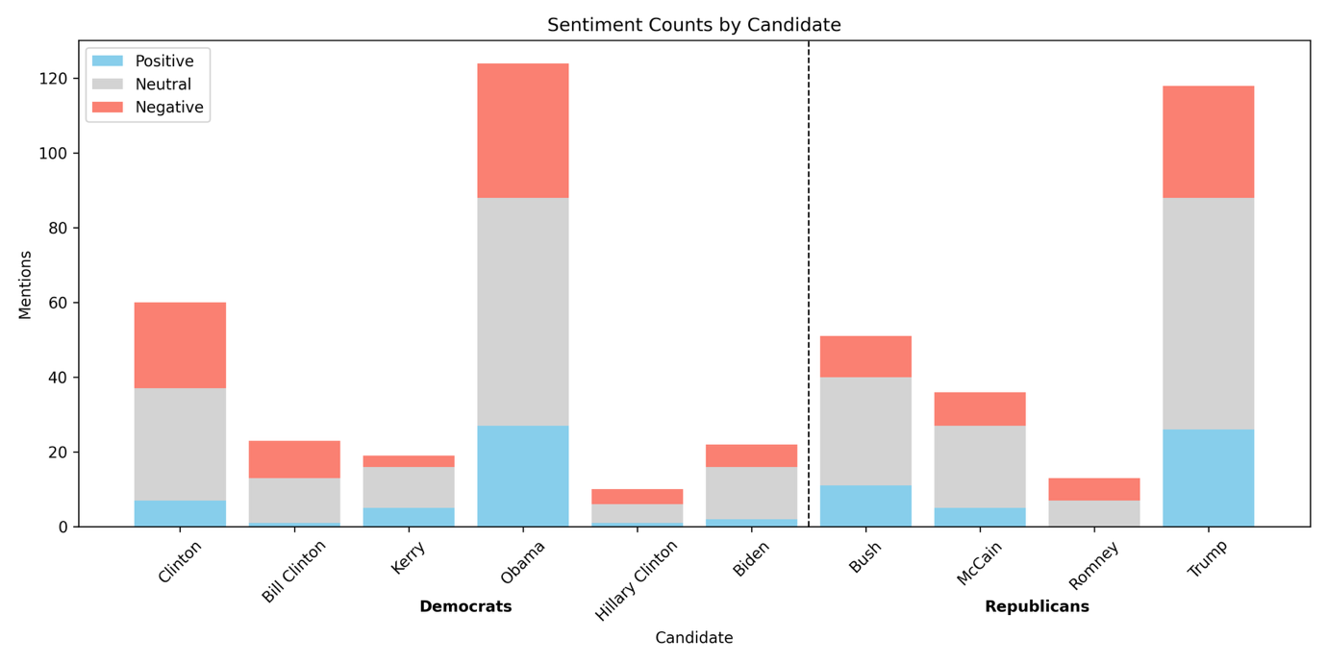

Top Sentence Blocks per Candidate

|  |  |  |
| --- | --- | --- |
| Label | Candidate | Sentence Block |
| Negative | Biden | OBAMA, and Joe Biden. Seems evil reports follow Obama from the first. Then President 45, Donald Trump. |
| Negative | Bush | When their breath departs, they return to the earth; on that very day their plans perish. In the words of one of my colleagues from a blog post this week, Donald Trump and Hilary Clinton are not gods. And I might add that neither is Barack Obama, or the Bushes, or any others. |
| Negative | Clinton | C. surrounded by officials and President Bill Clinton she declared I feel that the greatest destroyer of peace today is abortion. It is a direct war against the child, a direct killing of an innocent child. |
| Negative | Bill Clinton | C. surrounded by officials and President Bill Clinton she declared I feel that the greatest destroyer of peace today is abortion. It is a direct war against the child, a direct killing of an innocent child. |
| Negative | Hillary Clinton | The polls back this up as 71 of seniors say they are stressed and half of all adults are experiencing anxiety during this election season. On the other end of the age spectrum, according to one study, 1 in 4 millennials would rather the earth get hit by a giant meteor strike than have Donald Trump or Hillary Clinton in the White House. Here are some words that describe what many are feeling fear, anger, disgust, distrust, frustration, embarrassment, and hostility. |
| Negative | Kerry | Our country is divided into red and blue states and black and blue candidates. Both President Bush and Senator Kerry have practiced political polemics and have attacked each other's characters. One political commentator put it this way: Destroying the opposition rather than just winning the election seems to have become the trend in recent campaigns. |
| Negative | McCain | FinancesWe have a financial system that cannot seem to find its footing. Homes are being foreclosed onRetirement savings have been decimatedJobs are being lost by the thousandsThe Cost of living continues to riseThis is not only in America, but across much of the worldAdministration changeWe are in for a change of administration for sureWe are certain to have a president that scares a lot of people, whether that is John McCain or Barak Obama. Societal changesWe live in a different society that we did 10 years ago. |
| Negative | Obama | Let's call it for what it is baby killing. And Obama recently signed into law a bill that allowed, not only partial birth abortion but that the baby could be killed if it is alive outside the womb. God says that is an abomination. |
| Negative | Romney | I thought Romney would win in a landslide. With broken promises, high unemployment, economic woes, deficient sky high and the lies and deception of Libya I didn't think there was any way the majority of American's would vote for Obama. I didn't realize how effective his negative campaigning worked and how unaware, uninformed and uneducated the majority of the American public is. |
| Negative | Trump | Again a pause, Do you know, he added, I cannot, for the life of me, figure out where. Trump's words expose and express the sadness of the people of this world. All the people in Hollywood, all the people in politics, all the people with their big bank accounts don't have the answer or a clue as to what really gives meaning to life. |
| Positive | Biden | someone is going to win. Either Biden or Trump. Someone will walk away a winner. |
| Positive | Bush | B. Following this bold tradition President Bush made the following proclamation concerning thanksgiving on November 21, 2008:Thanksgiving is a time for families and friends to gather together and express gratitude for all that we have been given, the freedoms we enjoy, and the loved ones who enrich our lives. We recognize that all of these blessings, and life itself, come not from the hand of man but from Almighty God. |
| Positive | Clinton | A good teacher inspires a thirst for learning that lasts a lifetime. Bill Clinton said that on August 5, 1993 during a ceremony honoring inductees into the teacher's Hall of Fame. Henry Brooks Adams said, Teachers affect eternity, they can never know the full range of their influence. |
| Positive | Bill Clinton | A good teacher inspires a thirst for learning that lasts a lifetime. Bill Clinton said that on August 5, 1993 during a ceremony honoring inductees into the teacher's Hall of Fame. Henry Brooks Adams said, Teachers affect eternity, they can never know the full range of their influence. |
| Positive | Hillary Clinton | That role is saved for one Our savior. His name isn't Donald Trump or Hillary Clinton. As Christians we believe His name is Jesus. |
| Positive | Kerry | This filter also operates in a third and very important way. I am indebted to my ministerial colleague, Kerry Robinson, for opening up the final verses of our passage through a sermon I heard him give at Yellow Creek Lake Camp meeting a couple of years ago. He was speaking on this issue of holiness and he pointed out that we often focus on verses 22 and 23 but we forget about verses 25 and 26. |
| Positive | McCain | Even if we criticize them, we can acknowledge their efforts to serve their country. Senator McCain showed an incredible amount of support which revealed his character during his concession speech. When people started booing that Obama had won, he shut them down and said that response was completely inappropriate. |
| Positive | Obama | Let's honor the king. Barack Obama is our king. He is our president. |
| Positive | Romney |  |
| Positive | Trump | ILL. - Early in 1989, when Donald Trump's bank account was still bulging, a writer asked Trump the inevitable question about what horizons were left to conquer. Right now, I'm genuinely enjoying myself, Trump replied. |

Exactly 1 Candidate Mentioned in Sentence Block:

Candidate Sentiment Ranking

|  |  |  |  |  |  |  |  |
| --- | --- | --- | --- | --- | --- | --- | --- |
| Rank | Name | Party | Total Mentions | Neu % | Pos % | Neg % | Pos - Neg % |
| 1 | Trump | Republican | 83 | 53.01 | 26.51 | 20.48 | 6.03 |
| 2 | Bush | Republican | 26 | 65.38 | 19.23 | 15.38 | 3.85 |
| 3 | Obama | Democrat | 68 | 47.06 | 27.94 | 25.00 | 2.94 |
| 4 | Kerry | Democrat | 10 | 80.00 | 10.00 | 10.00 | 0.00 |
| 5 | Biden | Democrat | 8 | 62.50 | 12.50 | 25.00 | -12.50 |
| 6 | McCain | Republican | 6 | 50.00 | 16.67 | 33.33 | -16.66 |
| 7 | Clinton | Democrat | 35 | 40.00 | 17.14 | 42.86 | -25.72 |
| 8 | Hillary Clinton | Democrat | 5 | 60.00 | 0.00 | 40.00 | -40.00 |
| 9 | Bill Clinton | Democrat | 18 | 44.44 | 5.56 | 50.00 | -44.44 |
| 10 | Romney | Republican | 4 | 50.00 | 0.00 | 50.00 | -50.00 |

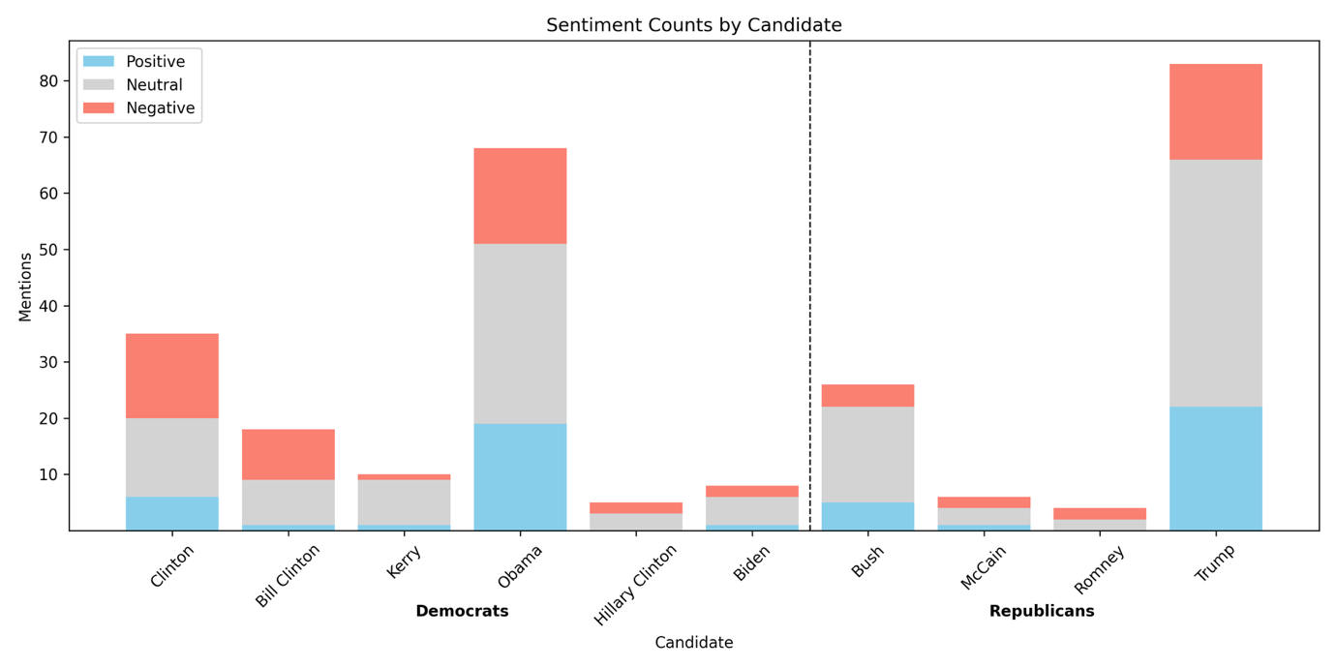

Top Sentence Blocks per Candidate

|  |  |  |
| --- | --- | --- |
| Label | Candidate | Sentence Block |
| Negative | Biden | We worry about our freedoms when the political winds change. Will Joe Biden and the Democrats clamp down on Christian freedom and condemn Biblical doctrines as hate speech. Or will we be able to maintain our freedoms to worship. |
| Negative | Bush | I hear religious scholars say, Islam is a peaceful religion. I heard President Bush recently say, Islam is a godly religion that has been hijacked. I respectfully disagree. |
| Negative | Clinton | C. surrounded by officials and President Bill Clinton she declared I feel that the greatest destroyer of peace today is abortion. It is a direct war against the child, a direct killing of an innocent child. |
| Negative | Bill Clinton | C. surrounded by officials and President Bill Clinton she declared I feel that the greatest destroyer of peace today is abortion. It is a direct war against the child, a direct killing of an innocent child. |
| Negative | Hillary Clinton | 83 a year after taxes. Those opposed to Hillary Clinton will point out that as a First Lady, Senator, and Secretary of State she never accomplished anything. Many accuse her of having an open marriage, allowing her husband the freedom to have affairs. |
| Negative | Kerry | You'll be congratulated for all your hard work, and you'll probably be given a job in the government somewhere that's your reward, if you want it, for working on the campaign for the winner. But if you were on John Kerry's campaign staff, then election day for you is not a good day. All your work didn't result in what you had hoped. |
| Negative | McCain | Obviously I couldn't finish it until I knew who won the election. Friends, this message is my effort, and would have been virtually identical had John McCain won the election, to see the hate stop among our citizens but even more among people of faith. I pray that I never see or hear about another situation like Mike and Buddy again. |
| Negative | Obama | Let's call it for what it is baby killing. And Obama recently signed into law a bill that allowed, not only partial birth abortion but that the baby could be killed if it is alive outside the womb. God says that is an abomination. |
| Negative | Romney | Conan O'Brien4. Today Mitt Romney visited a firehouse here in New York City. Of course, he was disappointed when he learned that the firehouse is not where you get to fire people. |
| Negative | Trump | Again a pause, Do you know, he added, I cannot, for the life of me, figure out where. Trump's words expose and express the sadness of the people of this world. All the people in Hollywood, all the people in politics, all the people with their big bank accounts don't have the answer or a clue as to what really gives meaning to life. |
| Positive | Biden | At one point, the interviewer spoke of how, under the economic proposals of his party, wealthier Americans would pay more taxes. Senator Biden defended the proposal saying, It's time to be patriotic time to jump in, time to be part of the deal, time to help get America out of the rut. Douglas K. |
| Positive | Bush | B. Following this bold tradition President Bush made the following proclamation concerning thanksgiving on November 21, 2008:Thanksgiving is a time for families and friends to gather together and express gratitude for all that we have been given, the freedoms we enjoy, and the loved ones who enrich our lives. We recognize that all of these blessings, and life itself, come not from the hand of man but from Almighty God. |
| Positive | Clinton | A good teacher inspires a thirst for learning that lasts a lifetime. Bill Clinton said that on August 5, 1993 during a ceremony honoring inductees into the teacher's Hall of Fame. Henry Brooks Adams said, Teachers affect eternity, they can never know the full range of their influence. |
| Positive | Bill Clinton | A good teacher inspires a thirst for learning that lasts a lifetime. Bill Clinton said that on August 5, 1993 during a ceremony honoring inductees into the teacher's Hall of Fame. Henry Brooks Adams said, Teachers affect eternity, they can never know the full range of their influence. |
| Positive | Hillary Clinton |  |
| Positive | Kerry | This filter also operates in a third and very important way. I am indebted to my ministerial colleague, Kerry Robinson, for opening up the final verses of our passage through a sermon I heard him give at Yellow Creek Lake Camp meeting a couple of years ago. He was speaking on this issue of holiness and he pointed out that we often focus on verses 22 and 23 but we forget about verses 25 and 26. |
| Positive | McCain | And ultimately, do what is right and do it with love. John McCain on CourageSource: Fast Company magazine's First Impression newsletter 8-2-06 Copied from Preaching Today Courage is like a muscle, the late US Senator John McCain said. The more we exercise it, the stronger it gets. |
| Positive | Obama | Let's honor the king. Barack Obama is our king. He is our president. |
| Positive | Romney |  |
| Positive | Trump | ILL. - Early in 1989, when Donald Trump's bank account was still bulging, a writer asked Trump the inevitable question about what horizons were left to conquer. Right now, I'm genuinely enjoying myself, Trump replied. |

## Topic Analysis

|  |  |  |  |  |  |  |  |  |  |
| --- | --- | --- | --- | --- | --- | --- | --- | --- | --- |
| Topic | Name | pre-Tuesday dummy | election year dummy | interaction | Constant | Mean Dep. Var. | Std. Dev. Dep. Var. | Adj. R² | N |
| all | All Topics | 0.00450 (0.00449) | 0.0167** (0.00816) | 0.0386*** (0.0112) | 0.121*** (0.00333) | 0.1311 | 0.3376 | 0.0027 | 26789 |
| outlier | Religion and Politics in Presidential Context | 0.00571 (0.00366) | 0.00114 (0.00634) | 0.0332*** (0.00900) | 0.0753*** (0.00269) | 0.0823 | 0.2749 | 0.0018 | 26789 |
| 0 | Religious Perspectives on Elections | -0.00149 (0.00272) | 0.0115** (0.00528) | 0.0173** (0.00728) | 0.0421*** (0.00205) | 0.0453 | 0.2080 | 0.0018 | 26789 |
| 1 | Church Leadership and Evangelism | -0.00122 (0.00155) | 0.00417 (0.00308) | 0.0182*** (0.00468) | 0.0135*** (0.00118) | 0.0156 | 0.1241 | 0.0029 | 26789 |
| 2 | Prayer for Political Leaders and Elections | 0.00110 (0.000980) | 0.00230 (0.00193) | 0.00858*** (0.00313) | 0.00469*** (0.000697) | 0.0067 | 0.0815 | 0.0018 | 26789 |
| 3 | Supreme Court and Judicial Decisions | 0.00109 (0.000865) | 0.00252 (0.00178) | 0.00408 (0.00271) | 0.00354*** (0.000606) | 0.0051 | 0.0711 | 0.0009 | 26789 |
| 4 | Economic Crisis and Government Response | 0.000658* (0.000363) | 0.00285** (0.00125) | 0.00186 (0.00190) | 0.000416** (0.000208) | 0.0015 | 0.0391 | 0.0017 | 26789 |
| 5 | Pro-Life Advocacy | -0.000491 (0.000573) | 0.000818 (0.00123) | 0.00552*** (0.00207) | 0.00198*** (0.000453) | 0.0025 | 0.0496 | 0.0014 | 26789 |
| 6 | Israel and Divine Election | 0.000615 (0.000409) | 0.00264** (0.00126) | -0.000474 (0.00168) | 0.000625** (0.000255) | 0.0014 | 0.0376 | 0.0006 | 26789 |
| 7 | Same-Sex Marriage Legislation and Constitutional Amendments | 0.0000761 (0.000402) | 0.000565 (0.000859) | 0.00261* (0.00148) | 0.000833*** (0.000294) | 0.0013 | 0.0356 | 0.0007 | 26789 |
| 8 | Biblical Leadership and Anointing of Kings | -0.0000644 (0.000230) | 0.00109 (0.000827) | -0.000993 (0.000905) | 0.000312* (0.000180) | 0.0004 | 0.0193 | 0.0001 | 26789 |
| 9 | Faith-Based Coping with Election Anxiety | 1.08e-16 (0.0000) | 0.000932 (0.000659) | 0.000429 (0.000947) | -1.57e-16 (0.0000) | 0.0002 | 0.0150 | 0.0009 | 26789 |
| 10 | Religion and Politics | 0.000315 (0.00117) | 0.00576** (0.00260) | 0.00637* (0.00374) | 0.00729*** (0.000868) | 0.0093 | 0.0958 | 0.0016 | 26789 |
| 11 | Religious Influence on Voting and Elections | 0.000975 (0.000684) | 0.00537*** (0.00191) | 0.00552* (0.00293) | 0.00208*** (0.000465) | 0.0043 | 0.0651 | 0.0031 | 26789 |
| 12 | U.S. Presidential Elections and Politics | -0.000927 (0.000913) | -0.00117 (0.00150) | 0.00877*** (0.00254) | 0.00489*** (0.000712) | 0.0051 | 0.0713 | 0.0009 | 26789 |
| 13 | Voting and Elections | 0.000489 (0.000443) | 0.00150 (0.00108) | 0.00262 (0.00177) | 0.000833*** (0.000294) | 0.0017 | 0.0410 | 0.0010 | 26789 |

Standard errors in parentheses

* p<0.1, ** p<0.05, *** p<0.01

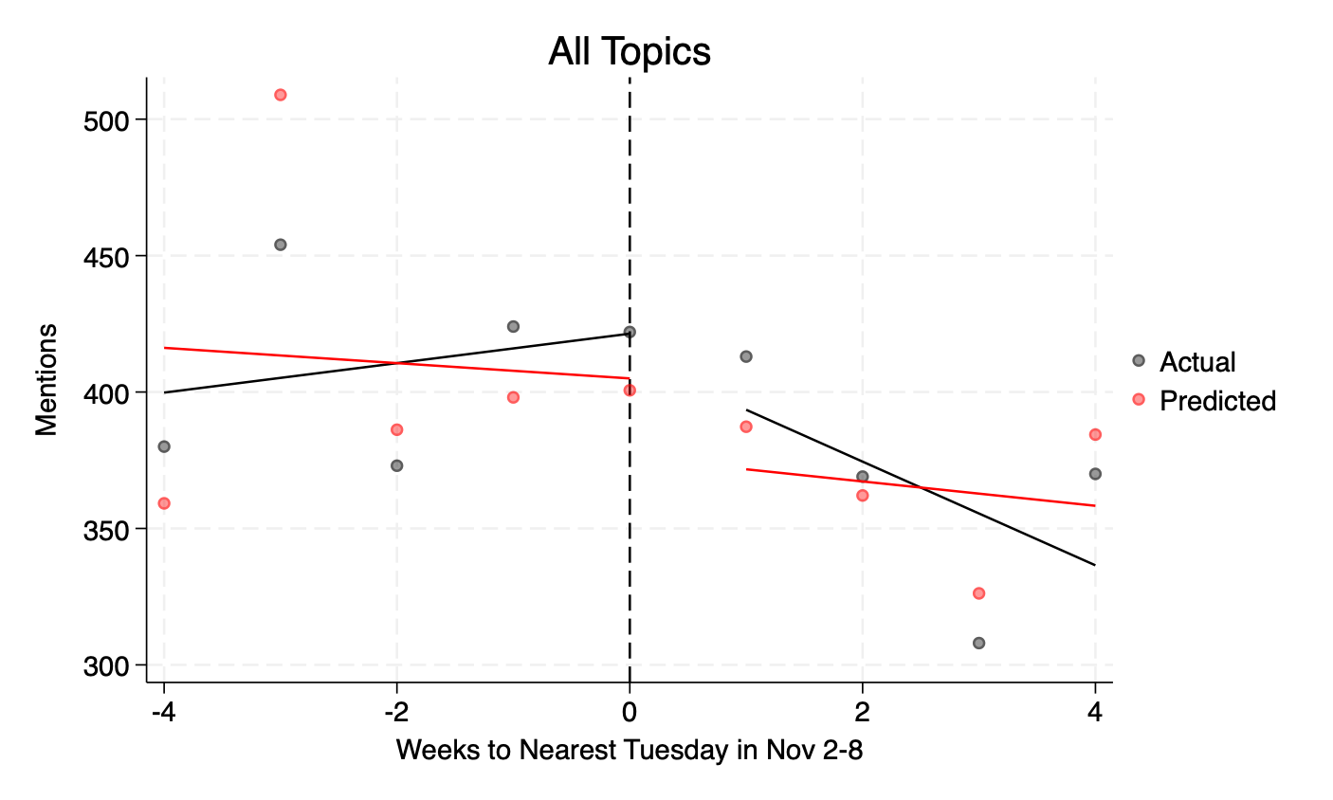 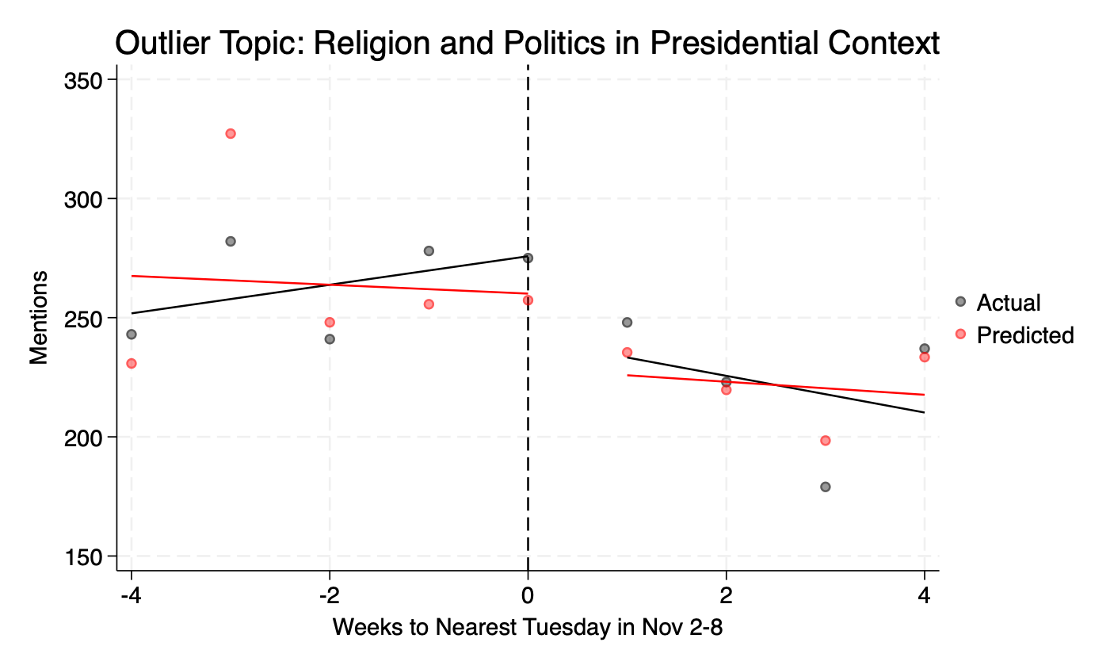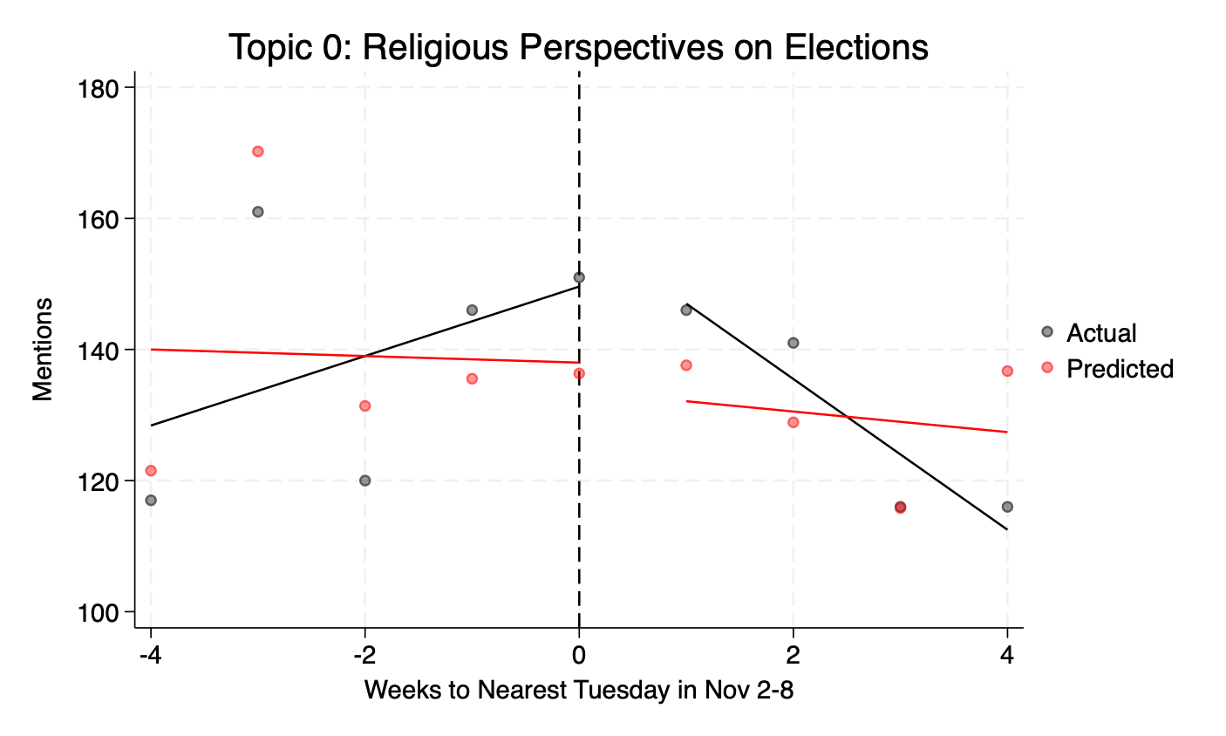 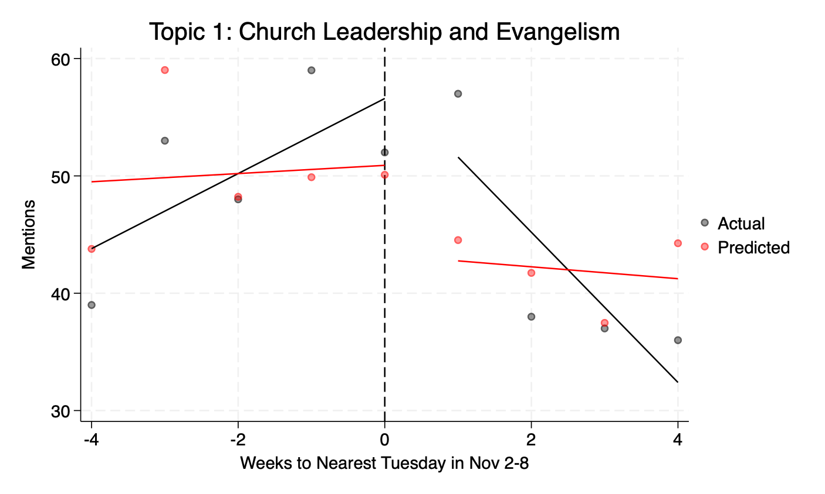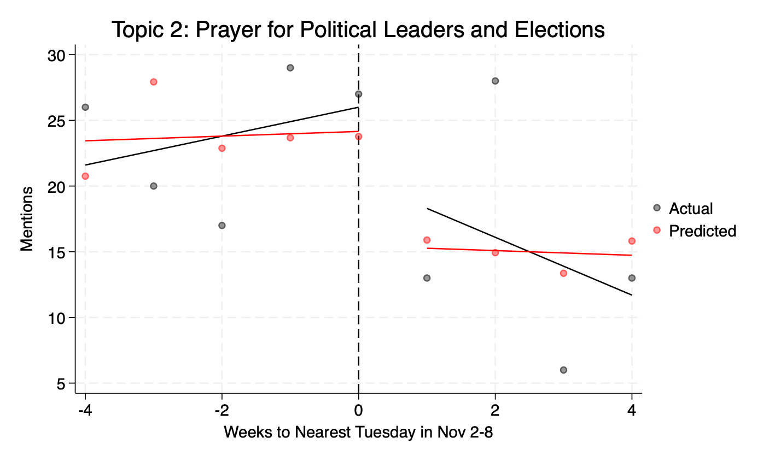 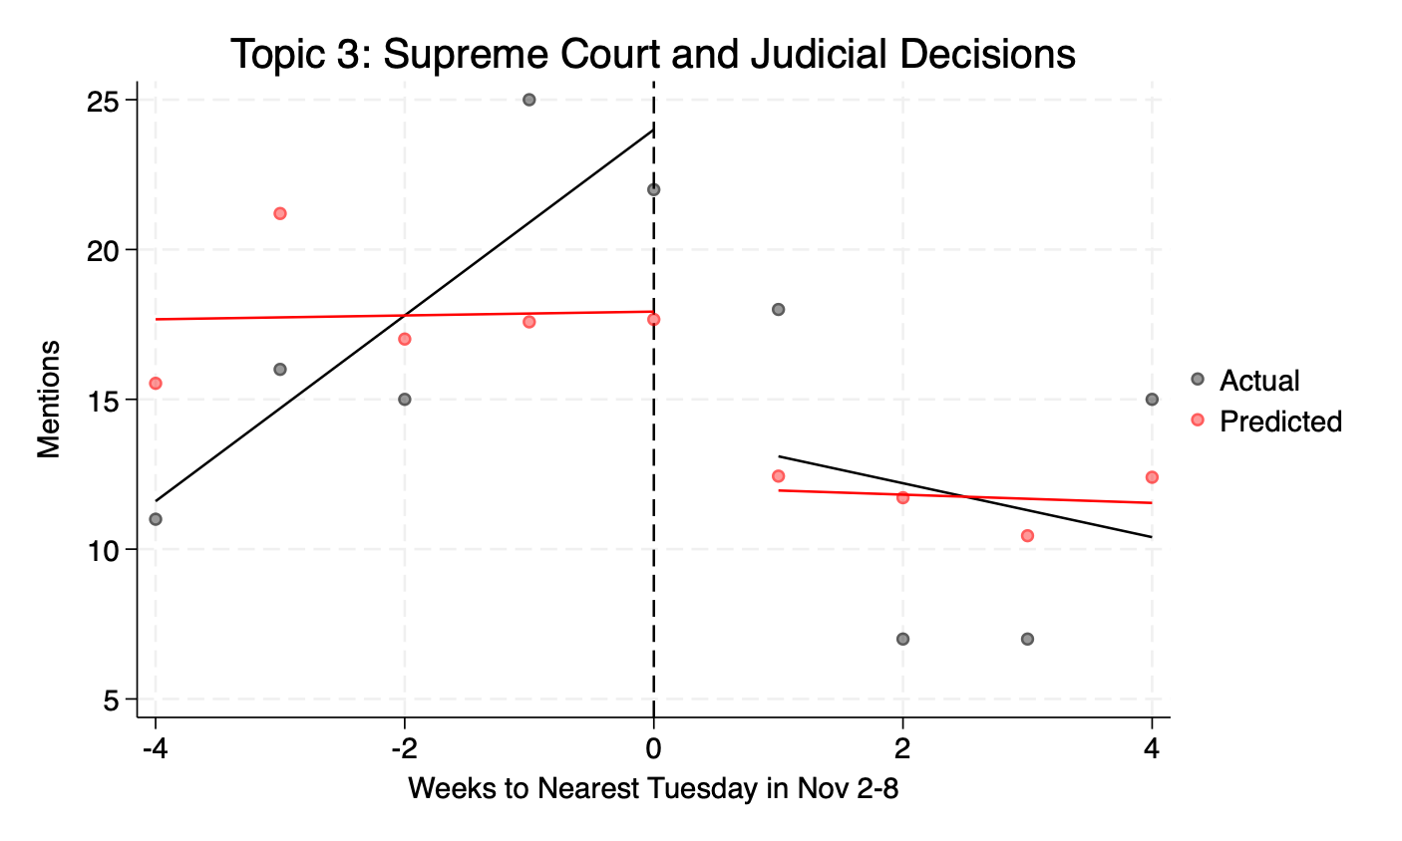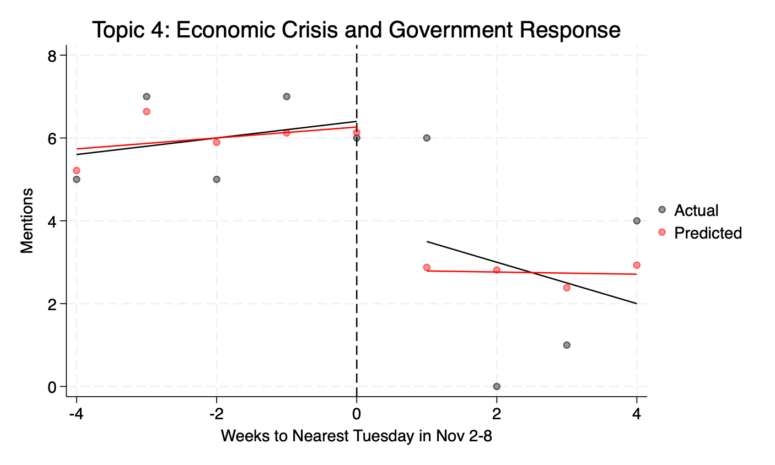 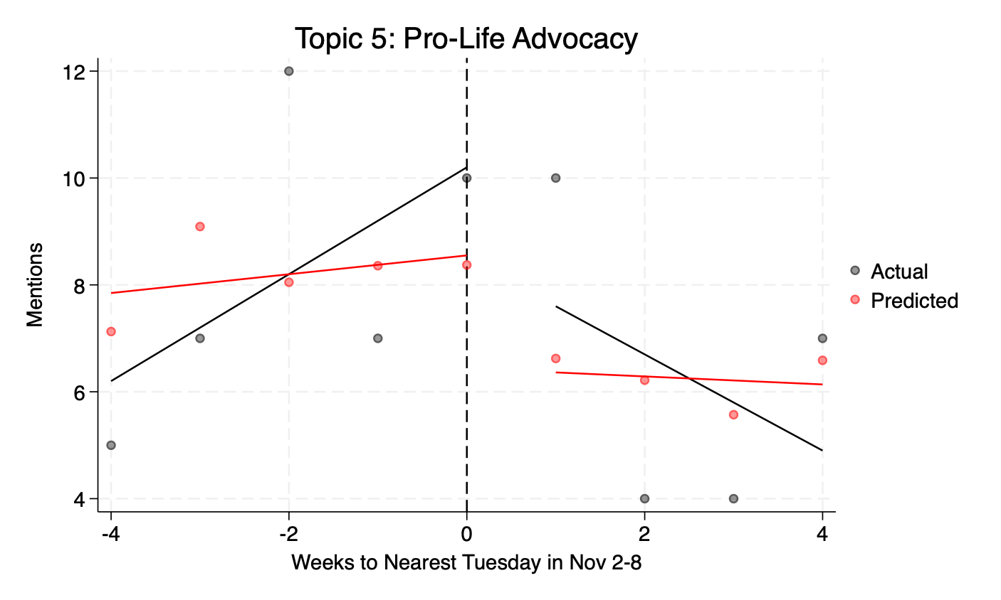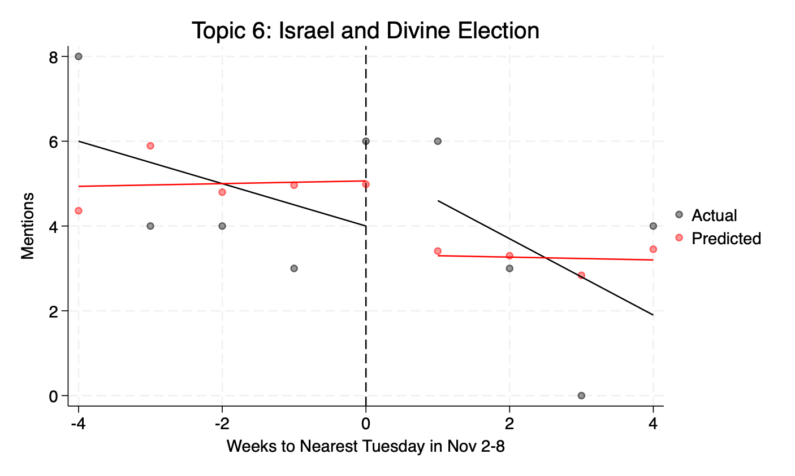 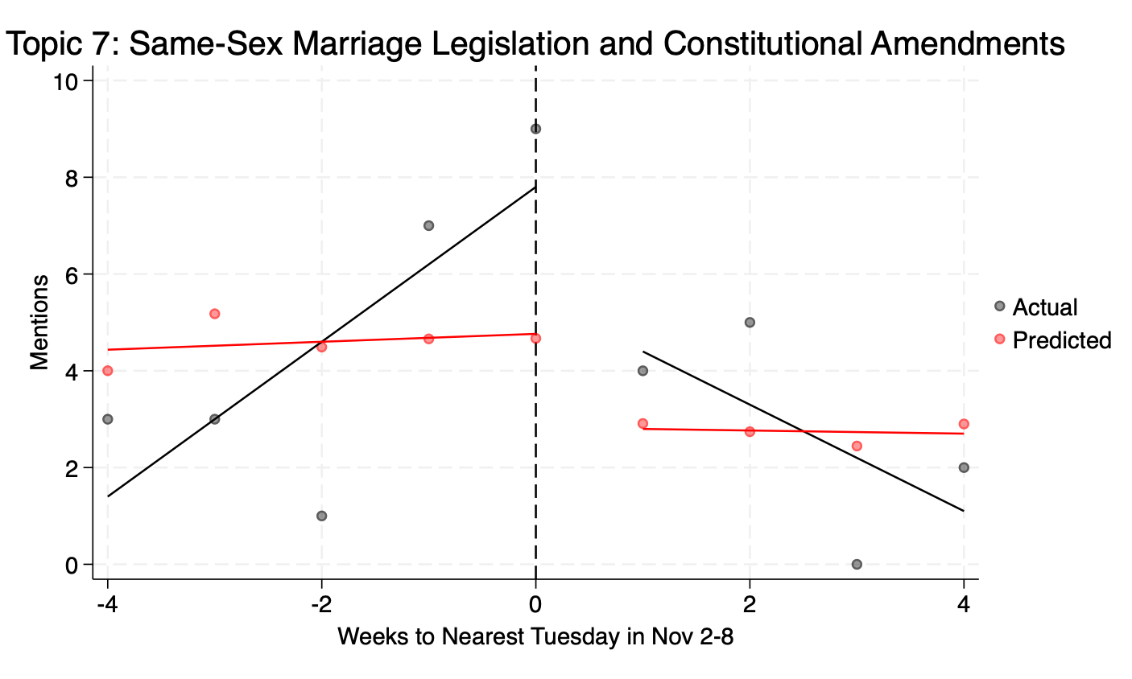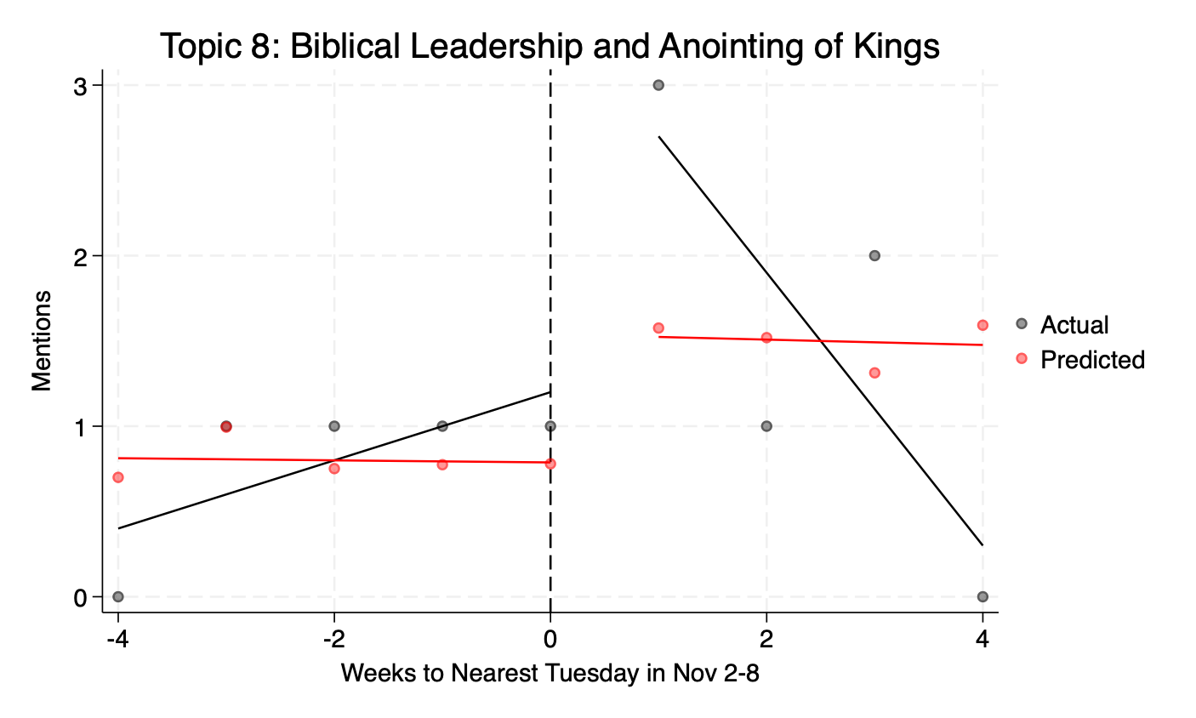 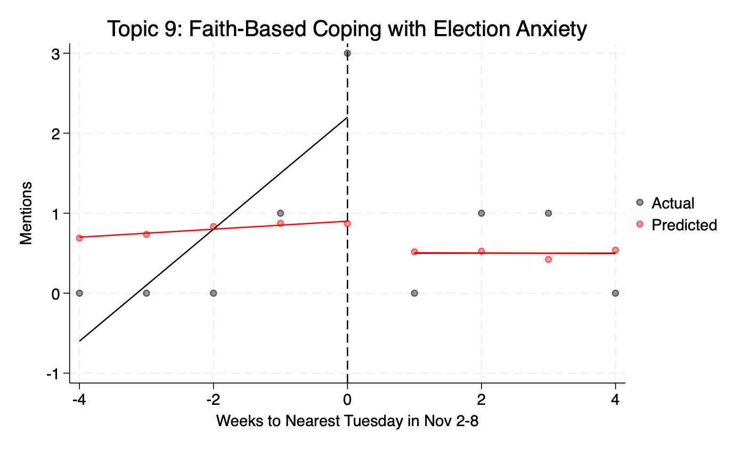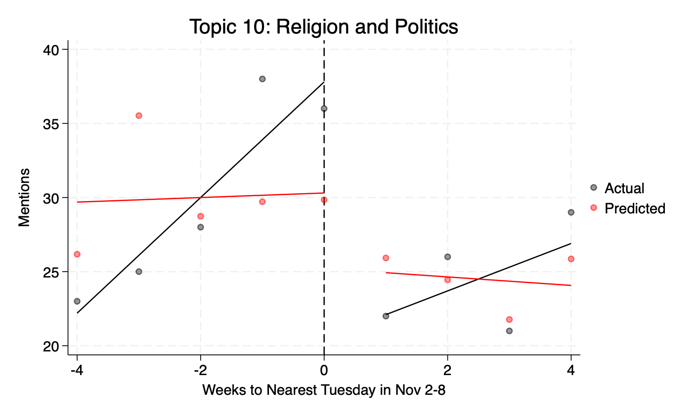 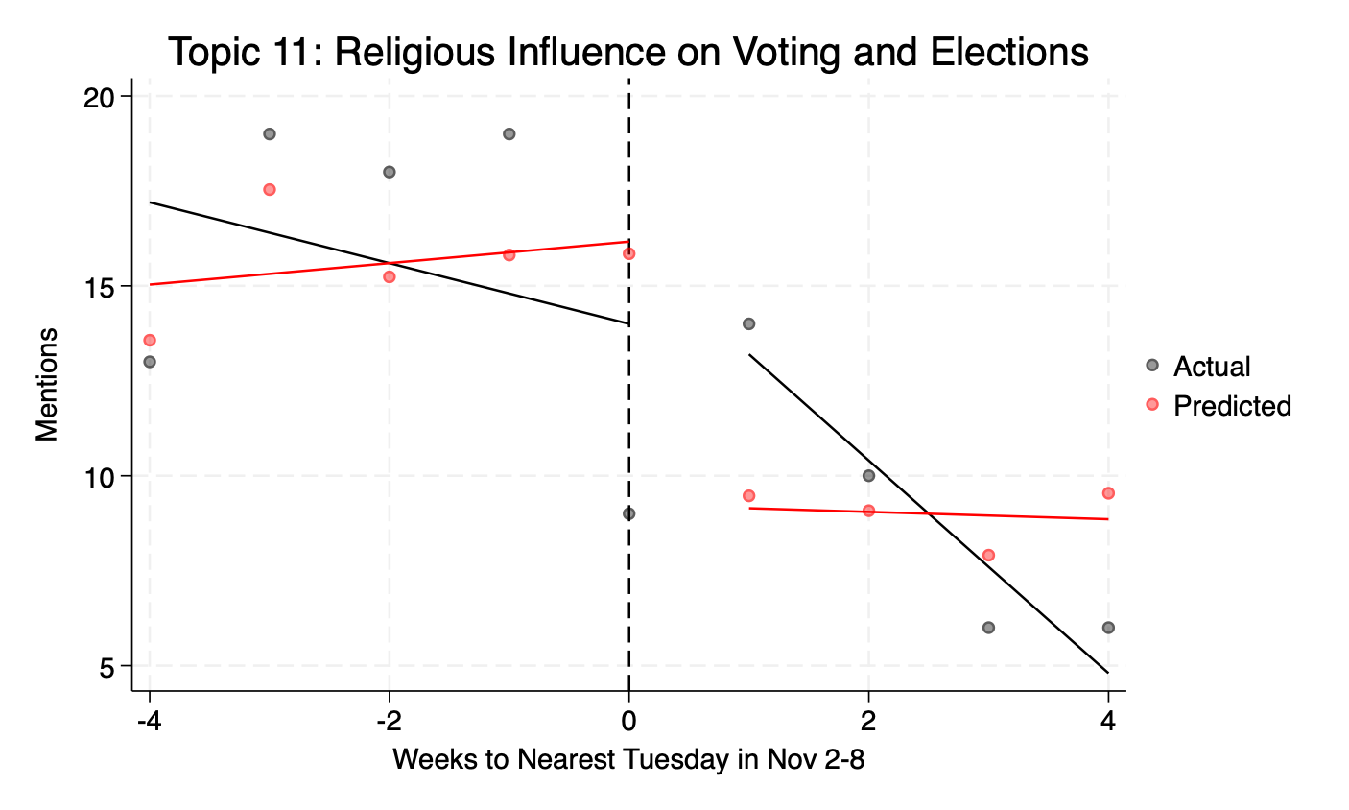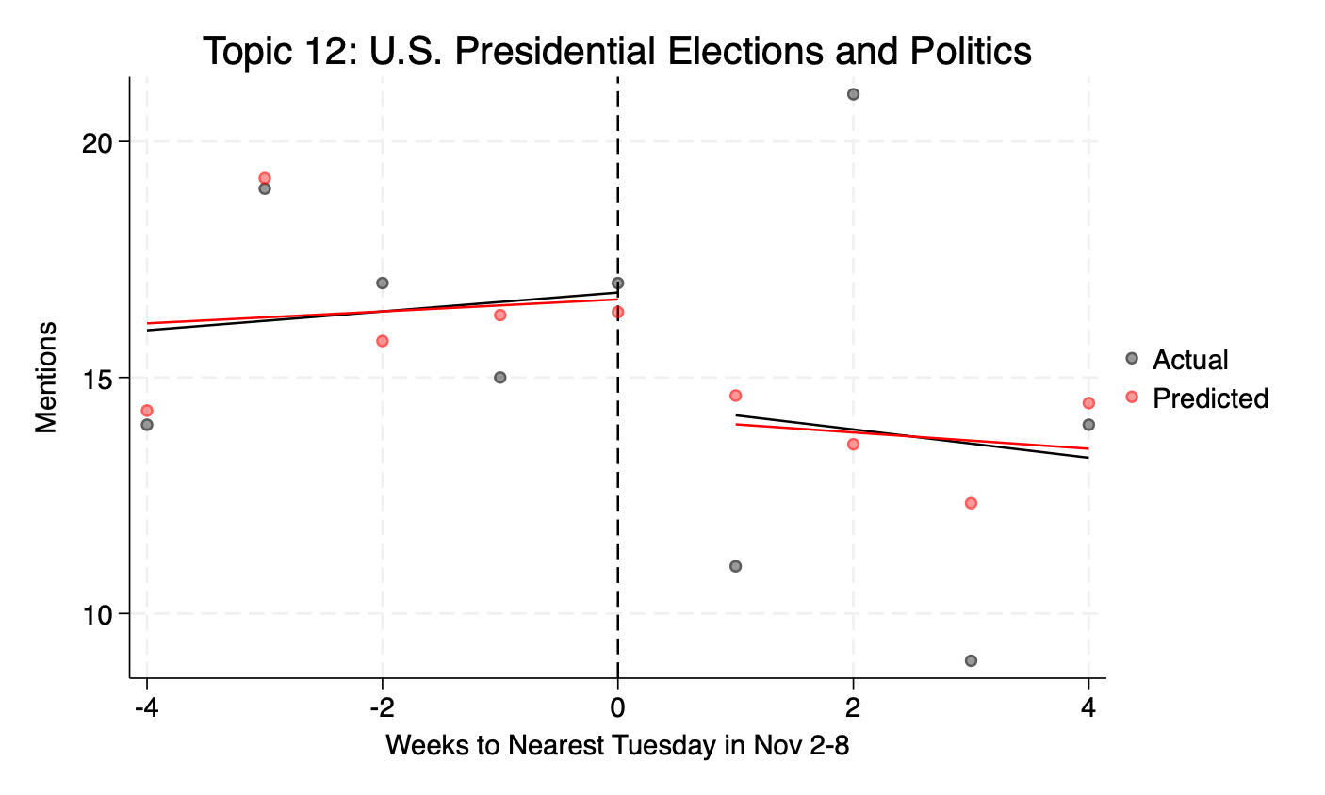 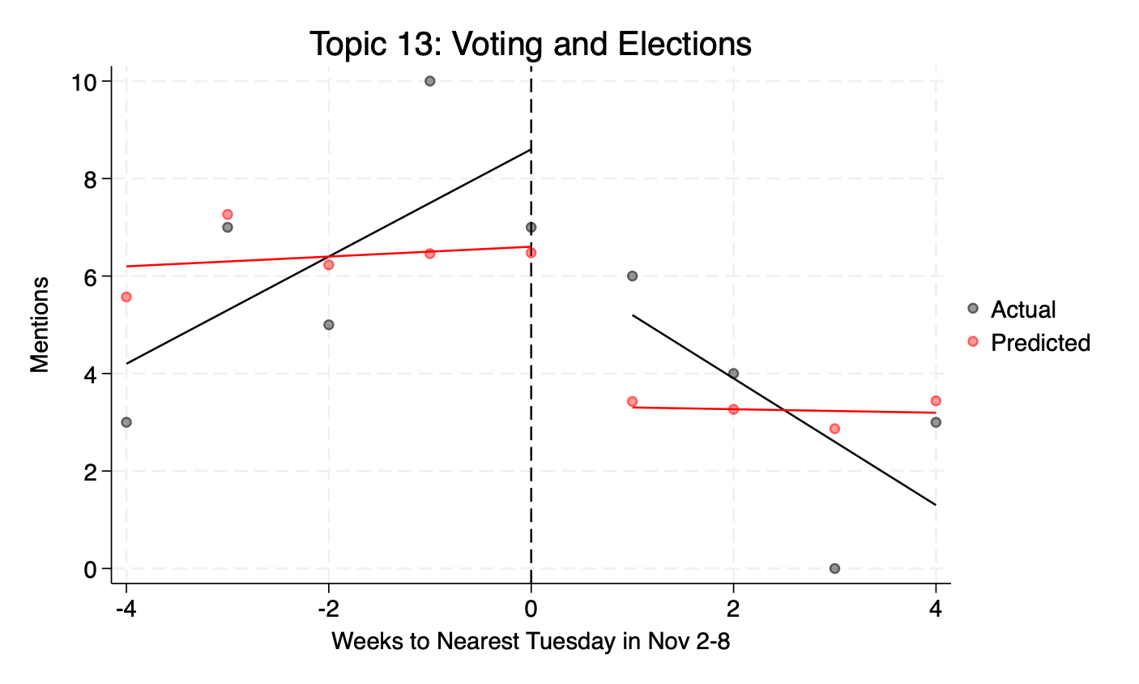

Outlier Topic: Religion and Politics in Presidential Context

Top 10 words: president, god, election, vote, people, can, would, from, nation, know

Example sentences:

1. Without the direction of the Holy Spirit, this concern can easily turn to slander, for some times there is a fine line between voicing a concern and gossip, and between help and hurt. George Bush the first made a trip to Australia during his term in office, when getting off the plane he decided to flash the reporters, tv crews and bystanders what he thought was the peace sign. What he accomplished was flying the entire nation the bird.
2. When I was a boy I got involved in stamp collecting. The hobby got a boost in the 1940's because President Roosevelt was an avid stamp collector and used the hobby as a means of escape from the burdens of his office. Well, the bug bit me when I was about nine years old.
3. What we do with the light we have is important. You and I have a responsibility to do what President Abraham Lincoln said at his second inaugural, with firmness in the right as God gives us to see the right Bro. Roy Harris writes that, The church should be the light that pierces the darkness of a nation in moral decline.
4. Why do I tell you about that. Did I tell you about that interview to get you all riled up against our President-elect. No.
5. We may choose to bind ourselves to one another in ways that are redemptive, powerful, and wonderful. We are a motley crew; but we can elect to be in chains, not as an imprisonment, but as a commitment. Let me call the roll, with Paul's help:The essence of prison is isolation.
6. Because we live by the principle of freedoms and not the power of fear - this is a threat to many nations and governments around the world. Our President sees the world very black and white with very little gray area, where much of the world is just the opposite. This is frightening to me as a Pastor.
7. They eventually returned to the United States with their health gone broke. They happened to be on the ship that former president Teddy Roosevelt was on as he returned from a big game hunt. When their ship docked in New York, the former president received an exceptional homecoming. The missionary work was much more significant, but no crowds greeted them.
8. Right. Jimmy Carter was president when we got married. He is a believer.
9. Man, I bet she's in trouble. President Carter got up from his chair, knelt down and simply said hey what do you need. He let her know that day there was nothing more important than her needs at that moment.
10. B God's growing of saints 1. 1 To build up the faith of God's elect. 1 Indwelling of the Holy Spirit2 Ingestion of the Holy Word3 Investment of Holy LeadersII.

Topic 0: Religious Perspectives on Elections

Top 10 words: god, president, elect, vote, election, from, jesus, shall, people, which

Example sentences:

1. While there are issues that the Bible does not speak about, there are things that we can apply Biblical principles to. We have an obligation to take a stand for morality and righteousness and in my mind that would include being informed about what candidates stand for and voting for those who support Biblical values and virtues. First let's consider the light that we have in the Word of God and what it provides.
2. Educate ourselves about where the candidates stand on the issuesAgain, I quote Bro. Roy Harris: Determining who we should vote for should not be a hard decision to make. This decision should transcend party identification, the latest poll, how our peers or family members plan or the suggestions of the media liberal or conservative.
3. John 15:16Ye have not chosen me, but I have chosen you, and ordained you, that ye should go and bring forth fruit, and that your fruit should remain: that whatsoever ye shall ask of the Father in my name, he may give it you. A much misunderstood verse the Bible concept of the elect and a subject for another message, but suffice it to say that the word chosen DOES NOT mean chosen without choice. We each have a free will.
4. Ill. it's a good thing that Abraham Lincoln wasn't a quitter...losing 9 elections, losing his fianc e, having a nervous breakdown, going bankrupt twice...and all before he became president and ended the atrocity of slavery. A lesser man would have given up long before.
5. We ought to look forward to the coming of Christiii. The Rescue of the Rapture - 1 Thessalonians 4:16-18 - 16For the Lord himself shall descend from heaven with a shout, with the voice of the archangel, and with the trump of God: and the dead in Christ shall rise first: 17Then we which are alive and remain shall be caught up together with them in the clouds, to meet the Lord in the air: and so shall we ever be with the Lord. 18Wherefore comfort one another with these words.
6. I. We understand the purpose of His purchaseA God's choosing of sinnersThe term elect in 1. 1 reminds us that God chooses us.
7. The second greatest tragedy of our nation is that he never sat in the White House. The first greatest is that Clinton did. MacArthur said, In war there is no substitute for victory.
8. They were and will be as the young folk would say; chillin. Prior to the Election, folk were pumped up but it seems like the political activist have fallen asleep again. Nothing has changed.
9. He is sleeping, Mr. President. He said not to disturb him.
10. No, Mr. President. I work for him, not you.

Topic 1: Church Leadership and Evangelism

Top 10 words: church, pastor, president, minister, preacher, candidate, would, years, churches, from

Example sentences:

1. Everything the church does, every energy that it expends, needs to be pointed toward this one thing ... redeeming and completing human beings. To paraphrase Bill Clinton's famous poster, It's the people, stupid. The seductive thing, you see, about church is that it is so easy to get lost in its activities and its traditions.
2. On that Sunday night in Richmond Hill, Georgia, the co-creator of the FAITH Sunday School Evangelism Strategy widely used in SBC churches, led by example as he shared the gospel at two homes. With a passion to see God seek and save the lost, the SBC president hopes The Everyone Can Kingdom Challenge for Evangelism will motivate the 16-million-member denomination to expand its outreach. Although membership in the Southern Baptist Convention continues to grow, there has been a decline in baptisms for four consecutive years, and Welch is praying for God to reverse that trend.
3. Division can easily happen in the church. If you can go back to 2016, after Trump defeated Clinton. Most people were in shock.
4. The difference will come in how the church responds. Will we fall apart and sob if our candidate doesn't win. Will we say this was a conspiracy.
5. - This same issue came up a few days ago. - It looks to be slated in June of 2021, the SBC May vote on a name change to greatcommission Baptist's. Q- What's the purpose of doing that.
6. I have a friend who is now a pastor in Kentucky. When he sensed God calling him to move into the pastorate from being a staff person, he had a church who dealt with him and, because of the influence of an unscrupulous member, voted down calling my friend as their pastor. So they went and got someone else to be their pastor.
7. Next, they each filled out an initial questionnaire and then met with our 5 elders for a deacon interview. Then they were recommended them to the church, and our church voted to call these men as deacons. Then they filled out a 6-page theological questionnaire and they each met with our active deacons and elders for an ordination council.
8. Dr. Rainer is the president of Lifeway Christian Resources. Lifeway is the publisher and bookstore that supplies much of the resources, Bible studies, curriculum - even our youth camp that our teenagers attend is under the umbrella of Lifeway.
9. I have some fine friends who pastor in the SBC, and there are many fine believers in their churches. However, since that time when the vote was passed by only a small majority, today the church is believed to be universal in nature and it is commonly accepted as such. Now the SBC calls itself the largest Protestant Denomination in America.
10. All in God's perfect timing. - Joe Stowell President of Cornerstone University, Grand Rapids, Michigan All history is in God's hand. He knows the best season for sending help to His church and new light to the world.

Topic 2: Prayer for Political Leaders and Elections

Top 10 words: pray, prayer, president, election, praying, people, god, can, would, categories

Example sentences:

1. , When there is a terror attack or a school shooting, we can either go buy a gun and a bunch of ammunition or we can pray. , When we have a presidential election in which we are forced to choose between two ungodly candidates, we can throw up our hands in despair or we can pray. If Jesus is genuinely my Lord, then prayer will be my first response, not my last resort.
2. 2 Pray this way for kings and all who are in authority so that we can live peaceful and quiet lives marked by godliness and dignity. 1 Timothy 2:1-2 NLT , What are some things based on this Scripture, and based on what you know about President Bush,, and based on what you know happens, after a president leaves office,, that we could pray about. , Ability to facilitate a smooth transition of power, Pray for his health and mental well being, Pray for the toll taken on his family over 8 years, Pray for his Godly influence on national and global issues in the years to come, Pray for him to continue growing in his faith2.
3. However, as I was using the internet for some research, I received a couple of emails which God used to speak to my heart about perhaps the most pressing issues facing us today. A lifelong friend Carolyn Byrd wrote and said, I don't think I have ever prayed this hard about an election. Another email quoted Dr.
4. Something in my spirit is very uneasy. In the past I have felt the need to pray for different elections but I have never felt so strongly the urge to pray, and pray fervently, for an election as I do for this one. I truly believe that if the wrong person is elected this nation will be changed forever.
5. We will pray for our newly elected political leaders to listen to the voice of God that many of them have silenced in their hearts. We will especially pray for Barack Obama, that he will not follow through on his promise to remove all restrictions on abortion, but rather embrace the gift of life. We will even pray for our enemies, for terrorists and those whose greed has brought our nation to its economic knees that they be converted and live.
6. What does that specifically mean. Starting today your prayers should be less about who you want to win the election and more about the heart and mind of both candidates and the ultimately winner being good servants of God. You prayer should be a prayer for salvation, wisdom, peace and love.
7. We need to pray for our leaders more than ever before. There are some people who hate our president just because he is black and would assassinate him if they could. We need to pray for his protection.
8. That is a good place to start. Yes pray for the President, the Supreme Court, and all in authority. Pray for them over and over.
9. A good example of this was reported by Time Magazine about a decade ago. The Congress was voting on a constitutional amendment allowing prayer in public places. Here are the attendance records: Members who voted in favor of the amendment: 224 Members present on the House floor for opening prayer on the three days preceding the vote: 18, 8, and 18. They talk and vote about prayer; they don't pray. 2 In listening to the politicians talk, use your reasoning, remember what the church has taught, call on your experience but, above all, hold them up to the light of Scripture before you cast your ballot. In the current crop of candidates I see two men vying for president. I would suggest that the differences between the two are considerable; so are the similarities: Both are imperfect Both would make mistakes in office Both have probably stretched the truth in their campaigns Both will likely have a lot of people to pay-back for their support in getting elected.
10. I Timothy 2:1-3I am not going to belabor this point there is no picking and choosing of which authorities for whom we want to pray and neglecting to do so for others. The text does not say we can pray for one president and curse another. Years ago, during a conversation with a brother-in-law and a nephew about the President of our country I was deliberately not offering much up in terms of what I thought. Finally my nephew said, You don't like the President do you. And I said, It's not a matter of whether I like the President or not I do think he has made some poor choices, but he is still our President. I do not have to agree with a President. I do not have to vote for a President. I do not have to support the policies of a President. I do not have to approve of the actions of a President. But I am obligated to pray for any and every President. And by praying for the President, I do not mean negative praying I mean praying that God will be with and bless and guide the leader of our land so that we may all live in peace and quietness and godliness and dignity. Conclusion:During the Civil War, then Treasury Secretary Salmon P.

Topic 3: Supreme Court and Judicial Decisions

Top 10 words: court, supreme, justices, judge, president, next, hear, unjust, avenge, put

Example sentences:

1. 6 THE SIGNATURE By Christ Jesus. A My check My signature Rockefeller's signature Donald Trump'ssignature. Jesus gives us a blank check with His signature on it and says, Just fill it inwith what you need, and I will provide it for you.
2. It will go down as a monumental day in constitutional law. Their decision on the case will not be made until June, but court observers and experts believe the 9 justices are split right down the middle, with Justice Kennedy likely making the deciding vote. In the course of the oral arguments, the justices questioned the attorneys on both sides of the issue.
3. They don't deal with individual defendants at all. Even the president can save a life, but he cannot take one. You could say that the people, the ones who elected the legislature and provided the jury are the ones to decide.
4. It is shocking to me that a Supreme Court that is supposed to be one third of the powers that govern the United States is the overwhelming power that governs the land. The supreme court can override the votes in congress, the very vote that is supposed to in turn be for the people. This isn't a democracy, it is nothing more than a country run by judges who are satanic agents of darkness who twist and bend the very constitution that was meant to establish and cherish biblical principles that our founders saw.
5. Making Godly DecisionsColossians 3:1-17Over the next 72 hours you who sit here will be making several crucial decisions. Decisions crucial to our nation who will be our next president. What will the character of our Supreme Court be what will the laws of the land be about religious liberty, Abortion, Partial Birth Abortion, Euthanasia, the definition of marriage, public prayer and a host of other things critical to the fabric of our nation.
6. 9But if anyone does not have them, he is nearsighted and blind, and has forgotten that he has been cleansed from his past sins. 10Therefore, my brothers, be all the more eager to make your calling and election sure. For if you do these things, you will never fall, 11and you will receive a rich welcome into the eternal kingdom of our Lord and Savior Jesus Christ.
7. 5. It's Obama's fault. 6.
8. 20 But if you have not acted in good faith, then may fire come out from Abimelech and devour the people of Shechem and Beth-millo; and may fire come out from the people of Shechem and Beth-millo and devour Abimelech. We need , To make the voting booth into a prayer booth. , To make God's choice our choice.
9. 6 Then the Lord said, Hear what the unjust judge said. 7 And shall God not avenge His own elect who cry out day and night to Him, though He bears long with them. 8 I tell you that He will avenge them speedily.
10. 30 that the hypocrite should not reign, lest the people be ensnared. Having just passed through the most horrible political election in my lifetime verses 16 and 17 ring so true - 16 If you have understanding, hear this; Listen to the sound of my words: 17 should one who hates justice govern. Will you condemn Him who is most just.

Topic 4: Economic Crisis and Government Response

Top 10 words: economy, money, president, government, issue, system, administration, crisis, financial, economic

Example sentences:

1. Senate Banking Committee Chairman Chris Dodd said on ABC's Good Morning America, some days ago that we're literally maybe days away from a complete meltdown of our financial system, with all the implications, here at home and globally. An extraordinarily costly plan was voted that is intended to address just the current crisis but it is not working yet as the President reasured us. This is the world that we live in.
2. Everybody wants to live as if they can afford everything. Borrowing more and more, spending more and more which means that the future is uncertain the use of this word - uncertain good politician. The US Government don't have enough money to pay for everything; SS, Medicare, the war, federal institutions... And no politicians dare to raise the taxes.
3. Because everybody trust this system Bust some day, when I will want back what left from my water, I will realize that is no water anymore It was consumed all for long time ago for other things, buying TVs from China and cars from Germany, financing the war, while I thought that I still have it in the bank -And everybody will be nervous about the real value of paper money. And one day I will try to pay as usual and I will be rejected sorry, I will not accept paper; I will accept only food or gas And people will panic, government will have to reinforce the law, any law voted by a frightened mob It will be the end The whole system will collapse We are not far from that day. Today we still using dollars, paper money or plastic And this is because we believe money still having value But this cannot last forever A rumor and bam.
4. Revelation 18 our Scripture Reading By the way, some put in the bank this big paper for retirement, and they will receive this a small one Loosing value Just some basic principles - economy This is not a lecture in economics. But we need this in order to understand something Come on Pastor, you are an alarmist Everything is fine, the crisis is over, they voted a plan and that's it. Let's here some nice things about Jesus love and forgiveness No, I am not an alarmist, I am a realist And I now Jesus loves me and loves you, because this is the reason He is warning us today.
5. I anticipate that US will walk away from its debt. New rules will be voted overnight and an authoritarian government will be ready to enforce them Sounds impossible. A year ago it was unthinkable to conceive how the Democrats and Republicans will come together, in unity to vote a law nationalizing the banks, a law that 80 of citizens is against it. Revelation 13 is right here Embargo; nobody sell or buy without belonging to their system.
6. -The economy. -The election. -Or something else going on in your life.
7. While our government has been systematically removing all things religious, or more specifically, all things Christian from our society, it has simultaneously been inserting itself into our culture as the great savior of those in need. Starting with Woodrow Wilson, the first Fabian Socialist President, through FDR with his massive social programs, to LBJ and his war on poverty, leading up to our current administration which has worked to increase the welfare and disability roles to such an extent that today, there are more people on government assistance than there are people working. All leading to the ultimate usurpation of the Church and the displacement of Jehovah God as the true source of hope and life.
8. Just tell me what's in it for me. It was barely 40 years ago, that President Kennedy said, Ask not what your country can do for you, but what you can do for your country. My how things have changed.
9. a culture of opportunity. I've talked to people who are voting this year based on how the economy is currently treating them. I don't think we should be one issue voters.
10. Is it politics. Is it the election. Is it the economy.

Topic 5: Pro-Life Advocacy

Top 10 words: abortion, life, pro, baby, research, cell, stem, issue, babies, unborn

Example sentences:

1. Of the 93 Members of the Freshman Class at least 77 are committed to defending the unborn. Almost every poll shows that Americans are becoming increasingly pro-life but in some recent elections we haven't voted that way. That has to change.
2. INTRODUCTION: This last four years has been a time of a semblance of a move back to the way America was founded. We have seen the challenge by our President to move away from immorality, and efforts to make the home and family strong. In the last 30 years we have seen more than 40 million babies aborted.
3. 5 million abortions a year. And if you help elect pro-abortion politicians to office because of your party affiliation, orbecause of your pocket book, then the blood of 2. 5 million innocent babies is on your handstoday.
4. You need to live under a rock not to realize that there is a clear choice between presidential candidates on the issue of protecting the most innocent, most helpless, and least powerful among us the unborn. I submit to you that it is gravely immoral to vote for someone who would at the first opportunity take my taxes and yours and use it for infanticide. Let's pray together that protecting life be THE issue on which our nation can unite.
5. It should be detestable to us as well. If we vote for someone who promotes abortion are we not an active participant in abortion. There is at least one candidate for the highest office in the land who promotes abortion at every level in every place on earth. That person even endorses what is called partial birth abortion which is the slaughter of a fully developed newborn infant who was delivered feet first so that only the head is still inside the mother.
6. But we have grown cold. We ought to march in Right to Life marches and vote only for those politicians who oppose abortion. That is one of my litmus tests of a Politian.
7. There are some of us under no circumstance will compromise some issues. I could never support a candidate who supports abortion. Let's call it for what it is baby killing.
8. Abortion, which I think is the 1 issue that Christ followers should be concerned about is not even mentioned as an issue until the 4th chapter. On John Kerry's website his Plan for America , is dominated by pocket book issues and security are among the eight major topics. On a page with 15 Other issues , abortion is not mentioned as a major topic but is discussed briefly on a page entitled Women.
9. When both parties agree that abortion should be rare, what is going on here. There is a lot at stake in this upcoming election regarding abortion. The stakes in the 2004 election:-Will you be required to pay for abortions abroad and in America. -Will parents be notified if their girl wants to have an abortion.
10. The abortion issue is a great issue in the presidential discussions. Obama when asked his views, gave the politically soothing answer: many women have suffered and it's beyond my pay grade to make that decision of when life begins. McCain, when asked when life begins, gave the simple answer, At Conception. Even when everyone goes against you at work or at school or in your neighborhood, never be afraid to stand up for the truth.

Topic 6: Israel and Divine Election

Top 10 words: israel, god, nations, america, nation, though, hope, land, truman, would

Example sentences:

1. God tells Israel that He didn't choose them because they are the majority. Compared to other nations they would not win the popular vote. It's not because they were bigger and it's NOT BECAUSE THEY WERE BETTER.
2. Who, really, would want to be known as the man who cost Israel our freedom. President Franklin D. Roosevelt said of December 7, 1941 that it was a day of infamy and that could easily have been said of that day in Israel's history if Israel more specifically, the designated champion/contestant would lose the battle.
3. Reason 2: Jews Are God's Chosen People. It's what many theologians call Divine Election. In 1993 the Soviet ambassador to the United Nations said, Zionism is a racist creed absurd ideology.
4. If we think that things improved after the time of the Judges, we are in for even more disappointment. The election of one city in Israel of a leader had proven to be a disaster. Perhaps if all Israel had elected a king, things would have turned out better.
5. Israel had been non-existent for nearly 2,000 years. And on May 14, 1948, a vote of nations gave Israel back its original land so that it might come together and form the nation of Israel once again. There are over 100 verses in the Old Testament that prophesied this occurrence.
6. There are over 100 verses in the Old Testament that prophesied this occurrence. At that time, the president of America, Harry S. Truman, signed the treaty to give Israel that land even though Congress demanded he not do it.
7. Truman, signed the treaty to give Israel that land even though Congress demanded he not do it. Why did President Truman sign that pact. His father was a preacher, and had taught Truman to bless the Jews in all he did.
8. C. , which brings us, guess what, to the exact date of May 15, 1948, the very day that a vote of the United Nations re-established the nation of Israel in the Promised Land. Now, just as God predicted through Isaiah, no other god, no other religion, and no other holy book displays such an incredible supernatural nature.
9. b. The Israelites were ready to elect new leaders and to stone those who opposed their rebellious plans. 6.
10. Israel in general failed to obtain what it was seeking. But, the elect obtained it. The rest were hardened.

Topic 7: Same-Sex Marriage Legislation and Constitutional Amendments

Top 10 words: marriage, gay, sex, states, state, adam, same, amendment, between, constitutional

Example sentences:

1. But over the past decade and a half, each of the 30 states to consider constitutional amendments that would outlaw such unions have adopted the ban from Alaska in 1998 to North Carolina earlier this year. That may change on Election Day, when voters in Maryland, Washington, Maine and Minnesota awash in money, messages and advertisements from both sides of the issue will make their decision on whether to recognize gay marriage It will be the first major test since President Obama in May became the first president to publicly state his support for gay marriage. This week, Obama also personally endorsed ballot measures in Maine, Maryland and Washington state that would legalize gay marriage; he has previously expressed opposition to efforts in Minnesota to pass a constitutional amendment barring same-sex marriage. I am thankful that 30 states have seen fit to adopt constitutional amendment's in support of traditional marriage and it is my hope that in the six states this year where same-sex marriage is being voted on that they will be defeated but whether they are or not there is only one definition of marriage that counts and it is the definition found in Genesis 2:Genesis 2:20 And Adam gave names to all cattle, and to the fowl of the air, and to every beast of the field; but for Adam there was not found an help meet for him. 21 And the LORD God caused a deep sleep to fall upon Adam, and he slept: and he took one of his ribs, and closed up the flesh instead thereof;22 And the rib, which the LORD God had taken from man, made he a woman, and brought her unto the man.
2. While in NC, Franklin Graham, Billy Graham's son, met with David Jeremiah and while they were visiting David said, I want you to know how much we appreciate what your father did in placing adds in the newspapers in North and South Carolina concerning the marriage amendments. That had a tremendous effect on the outcome of the vote. Some of you may know that North South Carolina had to do what so many states have done and that is to add a state constitutional amendment to define marriage between a man and a woman.
3. Some of you may know that North South Carolina had to do what so many states have done and that is to add a state constitutional amendment to define marriage between a man and a woman. Billy Graham urged N So Carolinians to vote biblical values and they did and they have the amendment. Jeremiah told Franklin that this is something that should happen nationwide, the Billy Graham should urge all Americans to vote biblical values. Franklin took it to his dad, Dr.
4. a culture for family. One of the big issues in the 2004 election, of course, revolves around the definition of marriage. Are homosexual unions right in the sight of God.
5. Have we disregarded the institution of marriage as they did. Today, we are allowing marriages between those of the same sex and there was even talk in California, when they voted on proposition 8, whether or not it would eventually be legal to marry groups of people together as one unit. Our society today has very much adapted all the sins and ills of those three previous periods of time.
6. Don't be unprepared. Know the names of the judges who stand for the values you hold, and vote for them. So, coming back to the passage, we need to honor marriage - and beyond the election, one of the key ways that we can do that is to maintain the purity of the marriage bed - the sexual relationship of our marriage. How do we dishonor our marriages.
7. He created Adam and Eve, not Adam and Steve. The people of Cali voted in 2004 on an amendment to make marriage one man, one woman. It passed and was instituted into their state constitution.
8. Earlier this year, the 4th District Federal court overturned the will of the people and redefined marriage as any union between consenting adults. The people of Cali were successful in getting it on a ballot again, and they will vote on it once more on Nov 4th. Preach'a, I don't live in Cali...pray for that state, because if marriage gets redefined there, we will be facing the same issue here in Texas.
9. Same-Sex Marriage. Four states Maine, Maryland, Minnesota, and Washington voted in same-sex marriage. This overturned the traditional interpretation of marriage.
10. We live in a culture that constantly wants us to accommodate to it. Just eight years ago the President and one of the current presidential candidates opposed homosexual marriage. Today, it is the law of the land.

Topic 8: Biblical Leadership and Anointing of Kings

Top 10 words: samuel, david, concession, king, lord, day, speech, horn, gave, oil

Example sentences:

1. . Election Day Confusion1 Samuel 16:1-13, The LORD said to Samuel, 'How long will you mourn for Saul, since I have rejected him as king over Israel. Fill your horn with oil and be on your way; I am sending you to Jesse of Bethlehem.
2. 13 So Samuel took the horn of oil and anointed him in the presence of his brothers, and from that day on the Spirit of the LORD came upon David in power. Would you vote for someone like Eliab if he were running for public office today. He was an impressive Old Testament character.
3. Besides being the eldest male in the family, he was a tall and handsome man to boot. Surely, we would vote for such a person to be our leader. After all, the famous prophet, Samuel, did.
4. The people felt as if He was irrelevant and unable to meet their needs as they advanced as a nation. Within the walls of our text, God, having lost the popular vote, and failed to secure the electoral votes conceded by giving a speech through His former running mate, the Honorable Prophet Samuel. The first thing we notice in our text is:I.
5. 6-9 a. The Bible says that the matter displeased Vice-President Samuel. But instead of protesting and picketing the fact that he was in the minority, Samuel prayed and called on the Lord.
6. b. Vice-President Samuel stood before the leaders and the people and uttered God's Concession Speech. i.
7. The difference between the Donald Trumps and the Davids is easy to see however. Donald Trump seems to be confident in his ability and his decision making ability. But David's confidence had a completely different source.
8. NAAMAN, THE MANIPULATING POLITICIAN1. Like all politicians, he thinks all problems are political problems and he made the mistake all politicians make: he turned to another politician to solve the problem. His king sends a letter with him to Israel's king.
9. Only blind Bartemeus who was by the highway side begging. - When David found favour with God, the boy who was despised by his relatives, the one who they would never have been presented for election to be king, became a celebrated person. Up till today we still talk about David.
10. 9. Pre-election-day, God warned His people:a When that day comes, you will cry out for relief from the king you have chosen, and the LORD will not answer you in that day. 1 Samuel 8:18 New International Version NIV b 1 Samuel 8:19-22 The people would not listen to Samuel.

Topic 9: Faith-Based Coping with Election Anxiety

Top 10 words: anxiety, election, attitude, positive, happy, panic, people, god, scenario, after

Example sentences:

1. Anxiety and Depression Association of America. , https://adaa.org/learn-from-us/from-the-experts/blog-posts/consumer/watching-new-making-your-anxiety-worse/tips] When this pandemic ends and it will end and this election is settled, we are can be guaran-teed of these basic truths. Whoever is president, God will still be on His throne. Jesus will still be King of Kings and Lord of Lords.
2. A panic that is giving itself over to fear that is rooted in a lack of confidence that I think is contrary to the biblical vision of God's sovereignty and the power of the gospel. Write this down Jesus is not running for President but He is running the universe. Psalm 22:28: For kingship belongs to the LORD, and he rules over the nations.
3. This morning we look at the words of the prophet Isaiah as he records Gods word concerning having a thirst for God and the promises that come in the word of God to those that know them and apply them to their lives and the warning that is given to those that do not. We are two days away from a big election. Anxiety is high, tension is high.
4. I'm simply saying that we can be people who are hopeful and Christlike in the face of it, okay. God/You:Four ways to keep a positive attitude after the election:1. Refuse to let worst case scenario thinking dominate.
5. Panic takes away your ability to think rationally through the situation and take appropriate action, even if the appropriate action is to do nothing and simply wait for help. So here's what I'm trying to say about how to keep a positive attitude about the election: don't panic. God's not freaking out about the election. God's not worried about who's in the White House.
6. We don't need worst case scenario thinking. The second way to keep a positive attitude after the election is to 2. Support our leaders.
7. But unless your life matches what you're talking about, then it's a lot of empty words. The fourth and last way I want to mention regarding having a positive attitude after the election is to 4. Live as hopeful citizens of heaven.
8. We would be ignorant at best if we fail to recognize the significance of this moment. The question for is this:As followers of Jesus how do we navigate the stress and anxiety of this election season in a gospel-centered way. We start with a simple act.
9. Instead Paul says, Philippians 4:6 Do not be anxious about anything, but in everything, by prayer and petition, with thanksgiving, present your requests to God. I have had a lot of conversations this past week with many people, myself included, that have shown great fear about what will happen if their candidate does not end up winning this presidential election. Can I tell you that goes against God.
10. , SLIDE 9, 1 Peter 5:6 7 HCSB Humble yourselves, therefore, under the mighty hand of God, so that He may exalt you at the proper time, 7 casting all your care on Him, because He cares about you. , Thinking back to what we are seeing in the aftermath of the election along with all the anxiety that happened during the campaigns. , Our fear of uncertainty caused a great deal of anxiety and vitriol.

Topic 10: Religion and Politics

Top 10 words: god, jesus, election, president, from, vote, candidate, can, going, know

Example sentences:

1. What's really cool, in the midst of all of this, is the fact that Jesus saw this coming. Actually, no part of this election process is a surprise to God. Jesus knew about the divisions we would experience.
2. . WOULD GOD VOTE FOR YOU. Candidates for Revival EZEKIEL 22:30 This will be presented over several weeks... much of outline courtesy Life Action Ministries.
3. Your talk is right, but there is nothing in your life to truly substantiate your position. How about if God were in the ballot box to vote as to whether you are going to heaven or going to hell, which do you think it would be. Well, I can tell you exactly what it would be.
4. That sin has already been paid for and can no longer be held against the sinner who comes before their Advocate in humble repentance for his crimes against the law of God. When Abraham Lincoln was President, his son Robert had A CLOSE FRIEND who entered the army as a private. Robert sent word to his friend, saying, Write to me, and I will intercede with Father and get you something better.
5. When they got together, Lincoln's friend said, I never took advantage of your offer, but you do not know what a comfort it was to me. Often after a weary march I would throw myself on the ground and say, 'If it becomes beyond human endurance, I can write to Bob Lincoln and get relief; and I would rather have his intercession than that of the President's cabinet, because he is the President's son. Christians have an even greater comfort.
6. Or let's make it personal Think about times in your personal life when your paradigm shifted. , In the week I finally made the last payment on my car , In the year I finally thought we were in good financial shape , Just when I thought we were getting to a good place in our marriage So here's the question: when your paradigm shifts when the world changes, when your foundation is rocked by the latest diagnosis or the latest cutbacks in your company or the latest election, is your concept of God big enough to handle it. Many years ago J.
7. And He is going to do the same thing here. God is going to give us our next president in order to turn this nation to Him. If we won't turn to Him in praise and thanksgiving then we will turn to Him in sorrow and judgment.
8. - Things are changing dramatically in our nation right now. NO MATTER WHO IS ELECTED PRESIDENT THIS TUE, our nation has forsaken God, allowing the forces of Satan to grow stronger stronger every day. - We are closer to either revival or judgment than we have ever been.
9. Follow me here put on your thinking caps: if a person rejects the true role of God in the life of Jesus, that person votes for the charge of blasphemy. And to cast your vote on the side of blasphemy to reject God's endorsement of Jesus is to say in your heart, Crucify him. Crucify him.
10. God will judge our apathy if we do not vote2. God will judge those who vote for a baby murdering candidate 3. God may hold off judgment a little longer if America votes correctly.

Topic 11: Religious Influence on Voting and Elections

Top 10 words: vote, election, government, from, people, god, political, christians, public, can

Example sentences:

1. b. Exercise our right to voteBut don't just vote, be a values voters. What happens when evangelicals vote their values. Here is an example in 2010: The American people have spoken, and replaced 38 pro-abortion Members with pro-life Members and replaced 14 unreliable Members with reliable pro-life Representatives, said Congressman Chris Smith, Co-Chairman of the Congressional Pro-life Caucus.
2. There have been numerous pandemics throughout history; the Black Death of the 14th century, Small Pox, Spanish Flu 1918-19 , HIV/AIDS, Hong Cong Flu 1968-70 to name just a few. Not only are we in the midst of a world-wide pandemic but a hotly contested national election. But we should not look to any political party to save us.
3. The alert was soon discovered to be a false alarm but for 38 minutes millions of people understood a little better how people who deal with chronic anxiety live every day. In this time of pandemic, election conflict, racial unrest, economic instability, monster hurricanes, and ravaging fires, people are experiencing higher levels of anxiety than ever before. If you have felt anxious in the last year, raise your hand.
4. What is it that Proverbs 11:11 says11Through the blessing of the upright a city is exalted, but by the mouth of the wicked it is destroyed. It is your God given right and responsibility to vote. But when you vote, you make sure that values, not economics, shapes your vote. Thomas Jefferson once said,The reason that Christianity is the best friend of government is because Christianity is the only religion in the world that deals with the heart.
5. It's been a long and trying year. Dealing with the virus, work stoppages, social injustices, sickness, uncertainty, the economics of it all, then the election. We're all running on fumes.
6. The name of our state is Chicago. not Illinois We have allowed Chicago to vote for our state. We have allowed Chicago to become the acting capitol of our state.
7. Let me make an application to our current cultural situation. Ever since the election everyone seems to be talking about evangelicals. Regardless of how you voted, this is an unprecedented opportunity because people are wondering what the term evangelical really means. Instead of defaulting to politics, let's declare the gospel, and when our words are not enough, let's show them what it means by how we live.
8. It'd be wonderful to free our country from its dependency on foreign oil. But such policies alone are NOT appropriate enough reasons to vote for one person over another, especially if that person also promotes values that are contrary to God's Word. God and His kingdom must always come before personal gain or desires.
9. We just went through the political season. And one of the main topics during the election was about the future of this country. The reason it was such a big topic is because the future can be a scary thing.
10. 1. We have gone through two storms these last 2 weeks- Lost of power have snow because of Sandy 10/29/12- Sandy dumped 3' wet snow- 270,000 people lost power- 6 people in WV have died- John Rose, 60, a Republican candidate killed by falling tree- It could take at least six months to clear fallen trees in some areas. - As of Fri.

Topic 12: U.S. Presidential Elections and Politics

Top 10 words: president, been, would, donald, election, said, 000, candidate, news, money

Example sentences:

1. This is the world that our children are growing up in. Several years ago Allen Greenspan, the President of Federal Reserve Bank, in a CNN Larry King talk show said: I encourage all Americans to tide their belts, spend less, borrow less, and save more, work hard because we are in recession, and we can pull out of it At that time, the national debt was equivalent with the all national assets. If you have 10,000 in your pocket, cash, and 10,000 debt, how much money do you have.
2. I don't know if you've figured out who that interview was with. But it was conducted by a Chicago Sun-Times religion reporter on March 27, 2004 as she sat down in a local coffee shop with then State Senator Barack Obama. Why do I tell you about that.
3. We all have the same amount of time. Whether we are penniless or whether we happen to be the richest person on earth, whether we are young or old, single or married, employed or without a job, an adolescent in school or the President of the United States of America-we have exactly the same amount of time page 67. From a sermon by Michael McCartney, Energy Conservation, 1/28/2010b.
4. And the money that is spent. Wall Street, Amazon, stores across the country, even the President will measure the progress of our country based on the amount of money we spend at this time of year. This was just released:Fortune magazine reported that this year consumers spent a record 69 billion dollars between Thursday and Sunday----during the long Thanksgiving Holiday weekend.
5. The purpose of distorting the facts is to get us to become afraid. Then we really don't know what we're voting for, because we tend to vote against someone. It would be nice if there could be no negative adds.
6. For out of the overflow of his heart his mouth speaks. By the way, that's why we should never discount the personal faith of a candidate. Political columnists will try to tell you that isn't important.
7. Then take Rod Blagojevich. He was impeached, removed from the office of governor, because he was trying to sell Barack Obama's vacant Senate seat. He's also in prison.
8. Monica Lewinsky is a name known by many. She is the former White House intern who had a scandalous affair with President Bill Clinton in the late 1990s. Since then, Lewinsky has lived in the shadow of public shame.
9. . Last season's new TV reality show The Apprentice centering around Donald Trump was a big hit. The 58 year old Trump commands an empire of over 100 companies, billions of dollars, and some of the most illustrious buildings in the world. The newest addition to the Trump kingdom is a massive skyscraper under construction in Chicago and that project is being supervised by Bill he winner of the first season of The Apprentice. This season began 10 days ago with a new group of business hopefuls vying for the job of a lifetime.
10. Bank and investment bank failures, business bankruptcies, the threatened collapse of Ford and GM, home foreclosures, a falling stock market, a falling dollar, a rising unemployment rate and the list goes on and on. A cartoon in the Houston Chronicle following the election summed up the situation our nation is facing quite well. It depicts a messenger delivering Barack Obama a message. The man said: Mr.

Topic 13: Voting and Elections

Top 10 words: vote, voted, right, votes, before, don, change, gave, can, sure

Example sentences:

1. Not every one of my candidates won, that's probably true for most of us. Part of the beauty of our country is we have the freedom to vote. That's part of what we were celebrating last week on Veteran's Day.
2. The first part of the report sounded great. They were all excited and the vote was unanimous. The land was flowing with milk and honey, they brought back grapes, pomegranates and figs as evidence of this great land.
3. Check out what one leader had to say about elections. , To vote, without fee or reward, for the person they judged most worthy. , To speak no evil of the person they voted against. , To care that their spirits were not sharpened against those who voted on the other side. John Wesley gave this advice on October 6, 1774.
4. This question is particularly urgent today, because tomorrow many of us will stand before ballots that have on them the clearest choice in modern history. I've never told you how to vote, and won't start today, but as we consider our sacred duty to act in support of those who have no power, it behooves us to remember the years 1960 and 1964 and their sequellae. Then, the nominally Catholic president and his successor were bringing change to the country. On the surface, the change was all good.
5. We the people obviously do not agree to disagree in false hope in lost faith for had it not been necessary to count all the votes for the good of the people, the process of counting all the votes before the people while the people watched day and night would have not begun on the first day of publicly counting votes not in the precincts but by the media. Do we need to know the truth of how the process of voting actually works in the United States of America. We lived a life of projections even predictions before the projections just like the weather forecasts: sometimes we get it more perfectly right than other times when we get it more perfectly wrong.
6. The farmer replied, Well, some of them said they weren't, but you KNOW how them politicians lie. 3 There's a reason why we must elect people of integrity our form of government is not a strict democracy we don't vote on everything. We elect representatives to do most of our voting for us. We choose them and then they go off to Washington to run things.
7. Folks, it doesn't matter who gets elected Republican or Democrat nothing in the direction of the nation is likely to change much. That shouldn't keep us from casting our vote, but if we want to see change, why don't we start right here in our community. We can change things here.
8. I had challenged each of you several months ago that you needed to do 3 things before the elections, 1. Register to vote. 2.
9. Almost no one votes against self-interest. We elect representatives to represent OUR interests. We want representatives who will bring home the bacon to our district, never mind that the interests of our district may stand in direct opposition to the interests of a neighboring district.
10. America is at the Precipice. Rather than voter disgust depriving us of the will to vote, it's more crucial than ever that we get involved in our representative government. 4.